106年國中教育會考
英 語 科 閱讀題本

第一部分：單題（第1-15題，共15題）
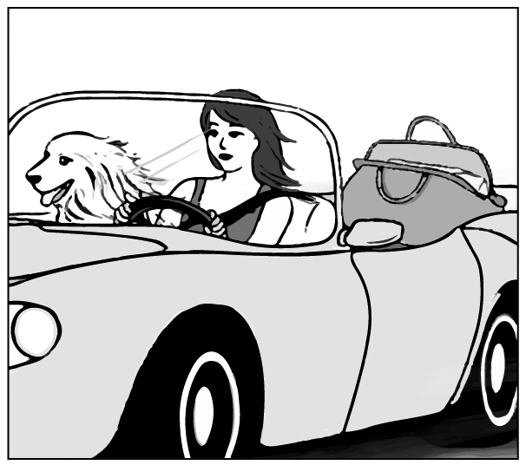
( ) 1. Look at the picture. The dog is sitting ________.
(A) on the bag
(B) next to the woman
(C) inside the bag
(D) between the woman and the bag
( ) 2. My sister wants to buy a car ________ she doesn’t have enough money.
(A) because (B) but
(C) if (D) or
( ) 3. Jim always forgets my birthday. He has asked me many times and still can’t ________ it.
(A) answer
(B) celebrate
(C) remember
(D) understand
( ) 4. The little girl was ________ by a truck on her way home and was badly hurt.
(A) hit (B) led (C) lost (D) paid
( ) 5. Excuse me. I really need to go now. My kids ________ for me at school.
(A) are waiting
(B) were waiting
(C) wait
(D) waited
( ) 6. Amy’s father is very sick. The doctors can do nothing for him, so Amy went to the temple to ________ for him.
(A) care (B) count
(C) look (D) pray
( ) 7. I’m glad that my school has students wear ________. I don’t have to worry about what clothes to wear to school.
(A) belts (B) caps
(C) gloves (D) uniforms
( ) 8. We are surprised that Sally and Ray decided to get married. No one knows ________. They often fight with each other and are unhappy together.
(A) why (B) where
(C) when (D) how
( ) 9. I don’t think Katie will read any one of the books you’ve picked out for her: ________ look(s) very boring.
(A) it (B) one
(C) some (D) they
( )10. Jenny’s bag is very heavy because ________ filled with toy cars.
(A) it is (B) they are
(C) there is (D) there are
( )11. ________ a map with you when you go to a place for the first time.
(A) Have taken (B) Take
(C) Taking (D) To take
( )12. The weather ________ rainy and cloudy in the last few days. I hope the sun will come out soon.
(A) has been (B) had been
(C) will be (D) would be
( )13. All the excuses Nick made ________ a lot about how much he hates to do the job.
(A) say (B) saying
(C) which say (D) to say
( )14. Sabine walks so ________ in the apartment that sometimes you don’t even know she’s just passed by. You wonder if her feet ever touch the floor.
(A) freely (B) lightly (C) shyly (D) slowly
( )15. In the past, people thought it was a ________ idea to send e-mails and read news online, but now it is part of our everyday life.
(A) simple (B) popular
(C) good (D) fresh
第二部分：題組（第16-41題，共26題）
（16-18）


Do you have some books you don’t want?
Your old love may be someone’s new favorite.
Bring one book to the Town Library & get another one home for free!
When & How:
March 2 - March 14 Bring one book for one book festival card.
March 16 - March 31 Bring one card for one book you like to read.
What books:
All kinds of books EXCEPT school books, comic books, and dictionaries.
Notice:
○ Your book must be in good shape, without any page missing.

○ Your book must be clean, and nothing is written on it.
Want to know more? Please call 1234-5678.
(We are closed on Mondays.)
-Town Library-
( )16. What is the book festival for?
(A) Selling second-hand books.
(B) Telling people how to choose books.
(C) Inviting people to change books with each other.
(D) Knowing what kinds of books are the most popular.
( )17. Sonja is busy packing some books for the book festival. Which is most likely one of them?
(A) An old dictionary of medicine.
(B) A book of short stories in English.
(C) A picture book with her own notes.
(D) A workbook she used in her math class.
 likely 可能
( )18. Look at the calendar. If Sean has a book festival card, when can he use it?
(A) March 3.
(B) March 14.
(C) March 23.
(D) March 29.
calendar 月曆
（19-21）
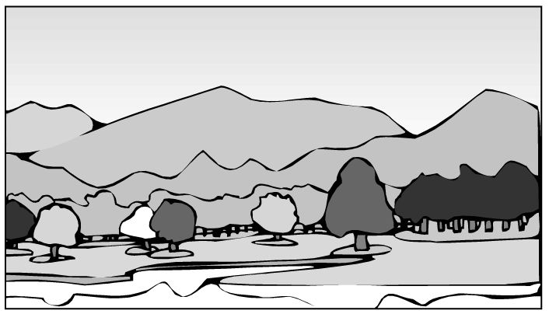
I had a horrendous experience last Saturday.
That day, my family went camping near a big lake. While my parents were preparing dinner, my brother and I were playing by the lake. A dirty man appeared from somewhere, and his face was half covered by his hair. He walked to us and asked for some water.
When I gave him water, the bag he carried dropped, and things inside fell out on the grass. I saw a rope, a knife, and a baseball bat. The strangest thing was that there were also a woman’s shoe and a ring, and I’m sure they were not his. The man quickly put all his things back in the bag and looked at us angrily. At that moment, the picture of a man the police was looking for came to my mind. He was the crazy killer! I was so afraid that I could not move at all.
Luckily, before he could get any closer, my mom shouted from far away, and the man hurried off into the dark.

( )19. What happened in the story?
(A) A killer was caught by the police.
(B) The writer’s family invited a stranger to dinner.
(C) The writer’s brother ran to their parents for help.
(D) A man ran away after he heard the writer’s mother’s
voice.
while 當…之時
( )20. What can we learn about the writer and the man with a bag?
(A) The man attacked the writer.
(B) The writer followed the man into the dark.
(C) The writer did not find out who the man was in the end.
(D) The man did not want the writer to see things in his bag.
( )21. How do people feel when they experience something horrendous?
(A) Angry. (B) Sad. (C) Scared. (D) Tired.
（22-24）
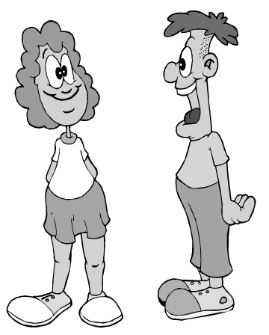
Ruth: I’ve got two tickets for a football game. The Lions vs. the Sharks, front-row seats, next Saturday. Interested? You can take Jessica to the game.
book 訂位
Nate: How did you get the tickets?! They were all sold out months ago!
Ruth: And a table for two at Leeds.
Nate: Leeds?! But I called them yesterday and they said they were all booked for the year!
Ruth: Now it’s yours. You and Jessica can have a lovely dinner there after the game.
Nate: Wait a second. This is just not like you. What’s the catch?
Ruth: Well, you know this Friday I’m leaving for my vacation in London, and....
Nate: And what?
Ruth: And I was thinking if Charlie could stay with you next week.
Nate: The whole week?!
Ruth: Please! I can’t just leave him in my apartment.
Nate: You know I hate that stupid dog! And he hates me too.
Ruth: Please! You’re my last hope.
Nate: I need to think about it.
Ruth: OK, but not too long.
( )22. What does the catch mean in the dialogue?
(A) A plan that starts well but ends badly.
(B) A fact that everyone knows but never talks about.
(C) A problem that is hidden behind something good.
(D) An action that is right in one way but wrong in another.
( )23. What does it mean in the dialogue?
(A) Taking care of Charlie.
(B) Having dinner with Jessica.
(C) Going to the football game.
(D) Going to London for vacation.
( )24. What do we know from the dialogue?
(A) Ruth will go to London next Saturday.
(B) Ruth had trouble booking a hotel room in London.
(C) Nate is the first person that Ruth thought of for help.
(D) Nate is surprised that Ruth was able to book a table at
Leeds.
（25-26）
drunk 酒醉的 law 法律
When you need to see a doctor, surely you will want to see a good one. But there is one important thing you may never have thought about: Has your doctor rested enough?

Doctors in our country often have to work 34 hours or longer without sleep. Most of them work 104 hours a week, and some even 150. (There are only 168 hours a week!) One report said that a doctor who works such long hours cannot think more clearly than a drunk driver. Another found that doctors who sleep 5.8 fewer hours than the week before might make 22% more serious mistakes. Surely no one wants to get in a car that is driven by a drunk driver. So, how safe would you feel when you are under the care of a tired doctor?

Sadly this problem has been around for a long time. There are no laws about it yet and hospital bosses don’t look like they care either. And that is why we doctors are asking you to join us on the street this Sunday. Fight together with us on the street so we can fight better for your life in the hospital.

 Time: 1 p.m. May 2nd
 Place: City Hospital Square

( )25. What is this reading for?
(A) Telling people rules about hospital visits.
(B) Getting people to stand up and speak for doctors.
(C) Telling people how to find a good doctor for themselves.
(D) Getting doctors to share their experiences in saving lives.
( )26. What does this problem mean in the reading?
(A) Doctors’ long working hours.
(B) Doctors’ problems with nurses.
(C) Doctors do not see enough people a day.
(D) Doctors are not paid enough for their work.
（27-28）

service charge 手續費
Have you ever seen a pumpkin that looks like a nose or an apple that looks like a funny face? They may not look great, but they taste just as good as the pretty ones. These strange-looking fruit and vegetables are called “seconds.” About 20-40% of what farmers grow is not so beautiful. Sadly, these “seconds” seldom arrive at your table, but often go straight into the trash can. Why? It’s because supermarkets don’t want to buy them from farmers—they believe their shoppers only love beautiful things. Because of these “seconds,” some farmers lose a lot of money.
Wonky Markt wishes to change this. We’re helping sell these “seconds.” Farmers can save them from the trash can, and you can get them at a lower price.
1. NT$250 a box.
2. You can choose as many as six kinds of fruit and vegetables a box.
3. Service charge: NT$50 a box.
4. No service charge if order is over NT$1,000.


Send us photos of your delicious dishes that are made with our “seconds” to oneandonly@wonkymarkt.com, and you may win our cookbook.

( )27. What does Wonky Markt care about?
(A) Supermarkets often sell “seconds” at a lower price.
(B) Farmers don’t know how to grow fewer “seconds.”
(C) “Seconds” are thrown away because of how they look.
(D) People don’t know much about picking fresh “seconds.
( )28. What do we know about buying the “seconds” from Wonky Markt?
(A) You can save 20-40% if you shop for a second time.
(B) If you buy three boxes, you will need to pay NT$900.
(C) You can choose not only their size but also their shape.
(D) To win the cookbook, you need to buy at least six boxes.
（29-30）
Below is the news about Dashing Shuttle’s bus line changes.
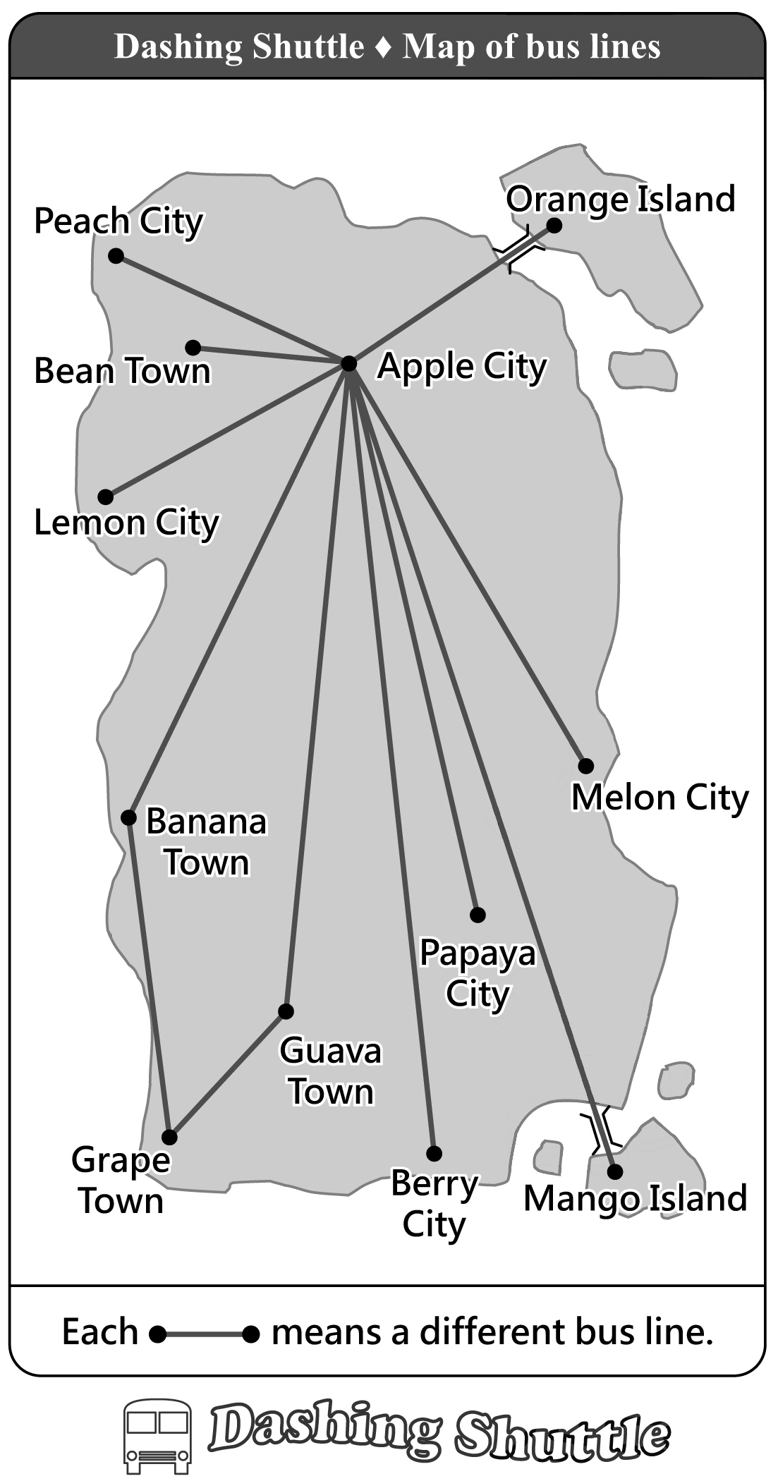 | 1. Great news for people who travel between Apple City and Peach City! From July 1, we have three more buses to Peach City every day.
 | 2. A trip from Apple City to Lemon City or Berry City will take less time. From July 1, you can go from Apple City to each of the two cities without changing buses.

3. Dashing Shuttle is the first in the country to open a bus line between Apple City and Orange Island. From July 1, our bus will take you to Orange Island every day!
4. Our bus line between Apple City and Grape Town will stop running on June 30. From July 1, changing buses at Guava Town or Banana Town will be the best way to travel.
5. From July 1, our bus runs from Apple City to Mango Island three times a day. You don’t need to change buses at Melon City anymore.

( )29. What can we learn from the reading?
(A) No buses go from Apple City to Orange Island before the
bus line changes.
(B) Before July 1, those who want to visit Mango Island have
to take a bus at Berry City.
(C) Traveling from Apple City to Grape Town will take less
time after the bus line changes.
(D) Before July 1, Dashing Shuttle does not have buses from
Apple City to Peach City.
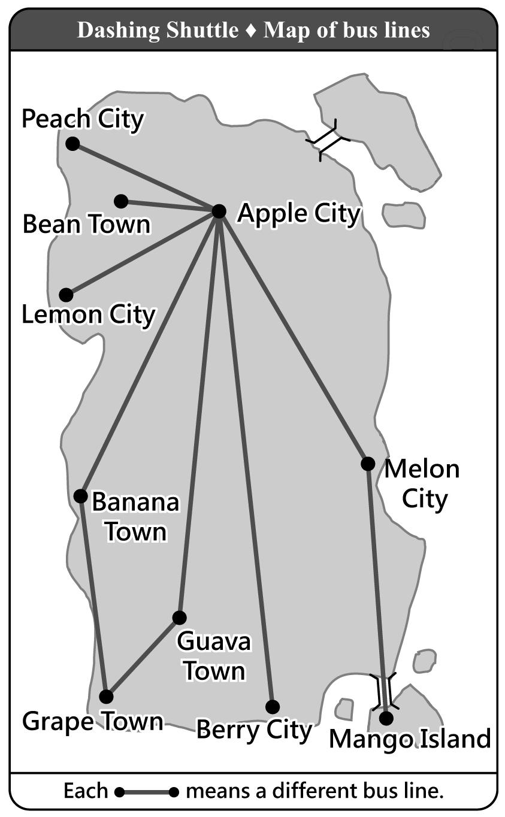
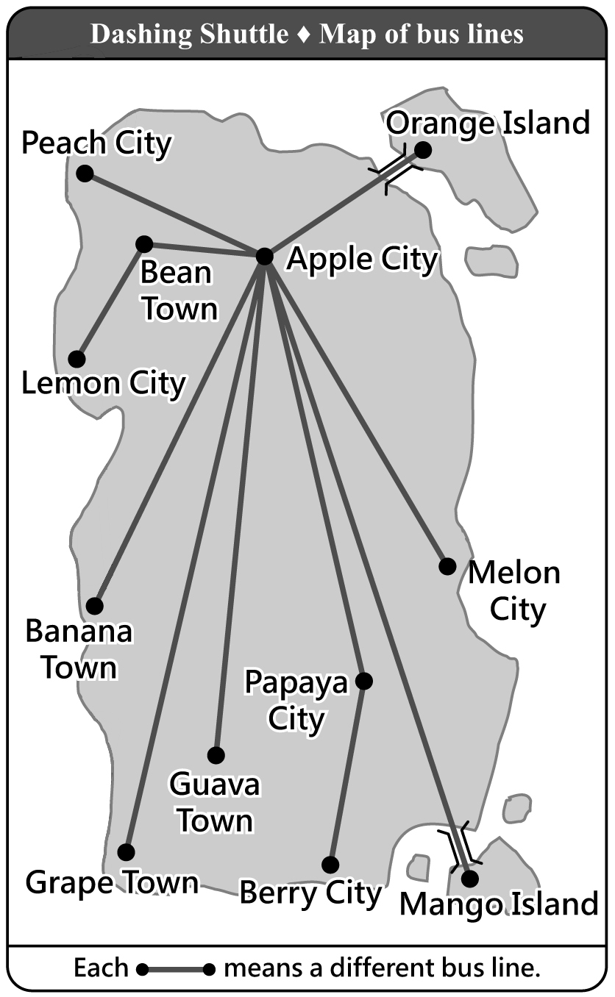
( )30. Which is most likely Dashing Shuttle’s map of bus lines before July 1?
(A) (B)
likely 可能
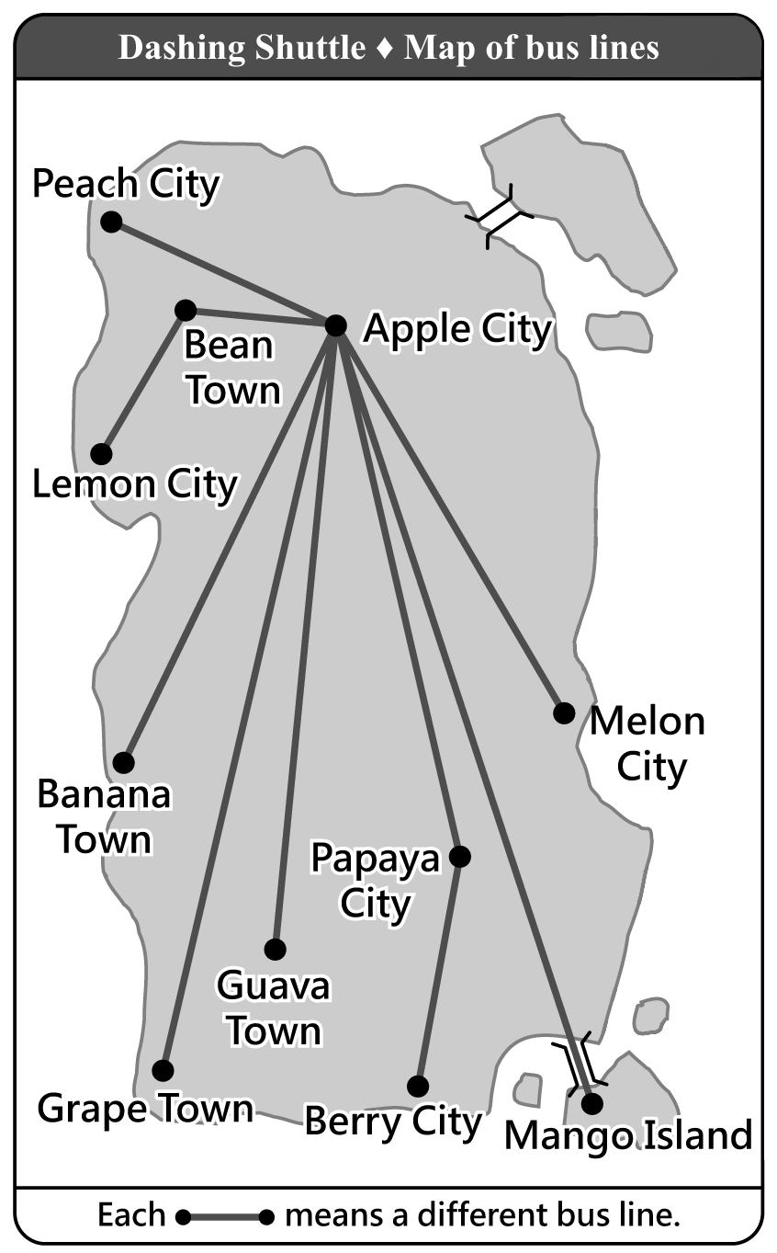
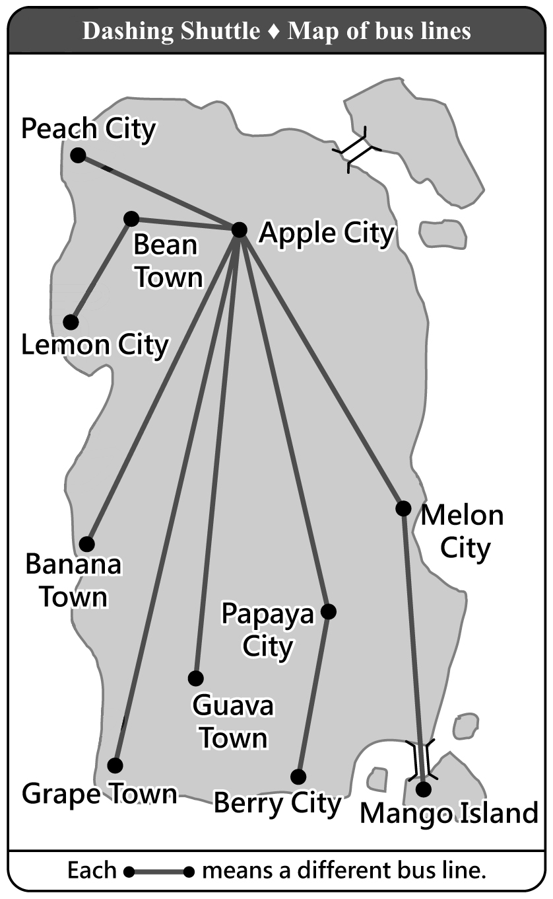
(C) (D)
（31-33）
Cinema Times
June 5th, 2005
Thanks to globalization, we get to see movies from around the world. If anyone should feel most excited about globalization, it is US movie makers. A study in 2001 shows that, for every 100 people who go to the theater, 85 see US movies. This may be good news for US movie makers, but not for those in other countries.
Chart 1 shows the percentages (%) of US movies in five countries in 1984 and in 2001; Chart 2 shows the percentages (%) of domestic movies in the five countries in 1984 and in 2001. In Chart 1, we can see that US movies have been popular in foreign markets. In Chart 2, we can see that domestic movies in the five countries are not doing well in their domestic market. The falling market for domestic movies may be a serious problem, but there is something more important. When people welcome US movies with open arms, they in fact also say yes to the American way of thinking. Some people in these countries worry that what is lost may not just be their domestic market for domestic movies, but also their own way of thinking that has been passed down from parents to children.
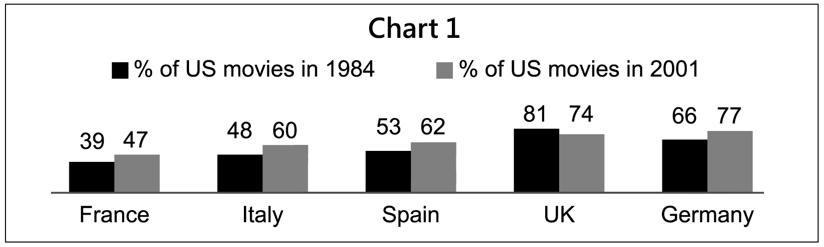
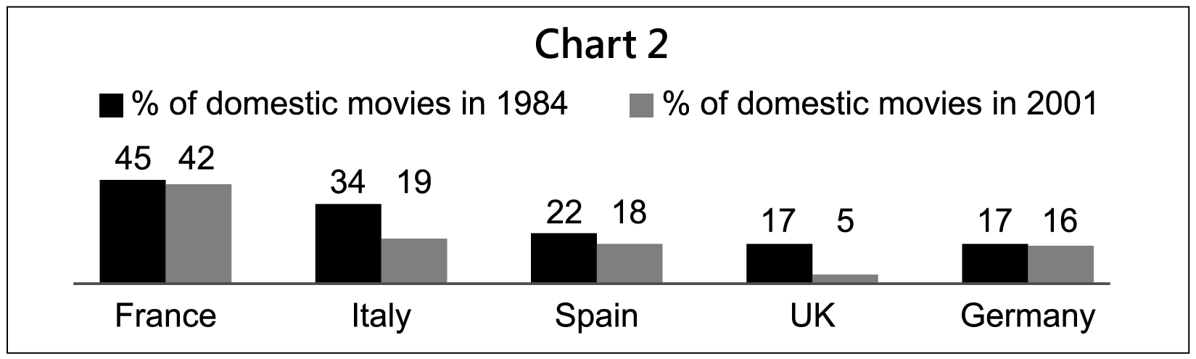
globalization 全球化
domestic 當地的；國產的；本國的

( )31. What does the report say about globalization’s influence on the movie world?
(A) It has changed the way of making movies.
(B) It has changed a country’s domestic market for movies.
(C) It has brought together movie makers from around the
world.
(D) It has helped US movies make more money abroad than
in the US.
influence 影響
( )32. What can we learn from the report?
(A) The American way of thinking may be changed
when it is brought to other countries.
(B) More and more people are asking their country to help their domestic movie business.
(C) US movies are popular in foreign markets because English is spoken in many countries.
(D) The fact that US movies are popular may mean the American way of thinking is popular.
( )33. From the charts, which is true?
(A) The percentage (%) of US movies has changed the
least in Spain.
(B) In each of the five countries, the percentage (%) of domestic movies has fallen.
(C) Of all five countries, UK’s domestic movies have the smallest drop in percentage (%).
(D) When the percentage (%) of domestic movies drops, the percentage of US movies rises.
（34-37）
Jerry Stevens has been unhappy these months. He a proud businessman of a successful shaved ice shop. His highest sales numbers were 1,899 plates a week; people called him “Ice King.” But all this changed when the cookie shop across the street started selling ice cream cookies. It took away half of his business.
And when Dan, his dead sister’s only son, came to work for him.
Dan was a nice young man with a simple mind, too simple, maybe. He always let people try some shaved ice for free, but he never learned to see when “some” became “too much.” Many people came, but few bought. When the sales did not grow with the heat, Jerry started to worry. He wanted to send Dan home. But how could he? Dan had no family except him.
Then, one day, . And it was from across the street. The cookie shop a clerk. For Jerry, it was a great chance to get Dan out of his store without sending him home. After taking the shopkeeper to several nice dinners, Jerry got Dan the job.
Now Jerry could finally try and save his store. And maybe Dan would help by sending him a few people who are thirsty from eating too many cookies.
shaved ice 刨冰
shaved ice 刨冰

( )34. (A) is
(B) has been
(C) used to be
(D) was going to be
( )35. (A) things didn’t get better
(B) he was ready to give up
(C) the sales of shaved ice finally started to rise
(D) the cookie shop was not successful for long
( )36. (A) his only hope died
(B) good news arrived
(C) worse trouble came
(D) the hard time passed
( )37. (A) used to look for
(B) has looked for
(C) was looking for
(D) had looked for
（38-41）
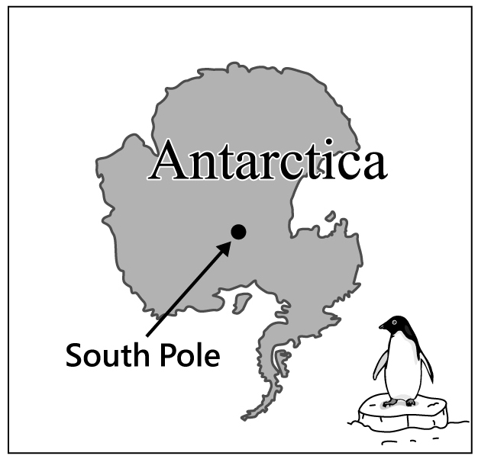
Englishman Robert Scott is known for leading two trips to Antarctica. The first one made him a star; the second .
After his first successful trip, Scott decided to be the first person to stand on the South Pole. However, . He would be in a race with Roald Amundsen, from Norway. Both left their countries by ship in June of 1910 and arrived in Antarctica in January of 1911.
About ten months later, both teams started their trips down to the South Pole. . Amundsen’s team used dogs, and Scott’s team used horses. Because horses weren’t good at traveling on snow, it took Scott’s team 77 days to arrive at the South Pole. They got there on January 17, 1912, and were surprised to find that Amundsen was ahead of them. The news hit Scott very hard, but what he didn’t know was that . His team began their long trip home with broken hearts. After days of terrible weather and little food, Scott lost his men one after another, and he himself was the last one to meet the end of his life. No one on his team lived to go back home and tell their story. It was only learned through Scott’s diary.
( )38. (A) hurt his health
(B) opened his eyes
(C) cost him his life
(D) made his dream come true
( )39. (A) he didn’t want to take this trip with others
(B) he wasn’t the only one who had this dream
(C) he wouldn’t let anyone else take his prize away
(D) he couldn’t miss the chance to make his country proud
( )40. (A) And Scott used a popular way for his men to travel fast
(B) But there were problems to deal with before they traveled
(C) But Amundsen didn’t know better about animals than
Scott
(D) And their ways of traveling decided which team would
win
( )41. (A) there was still hope
(B) no one ever believed him
(C) the worst had not come yet
(D) Amundsen had not been honest

106年國中教育會考
英 語 科 聽力題本

第一部分：辨識句意（第1-3題）
作答說明：每題均有三張圖片，請依據所聽到的句子，選出符合描述的圖片，每題播放兩次。
示例題：你會看到
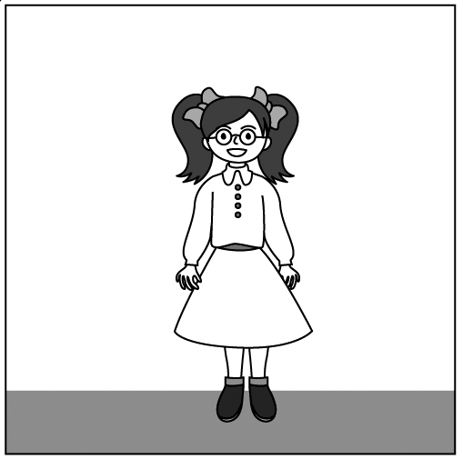  (A) | 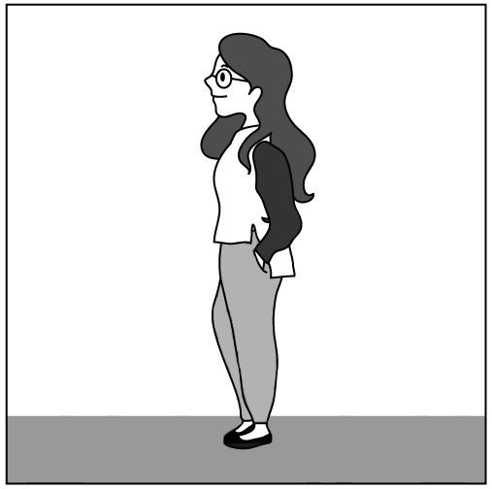  (B) | 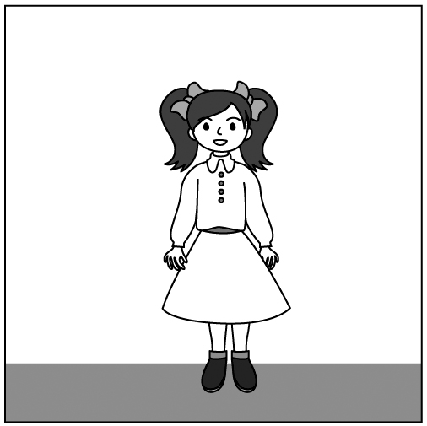  (C)
然後你會聽到……（播音）。依據所播放的內容，正確答案應該選A。
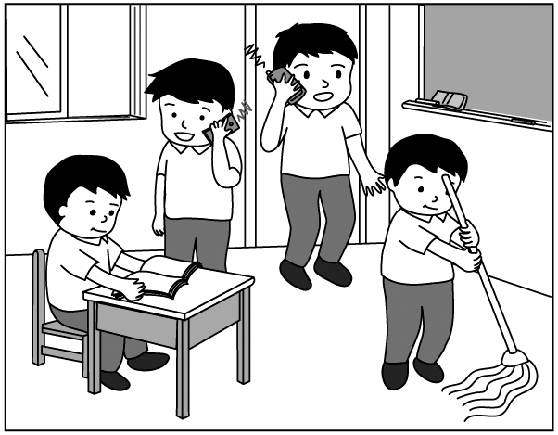
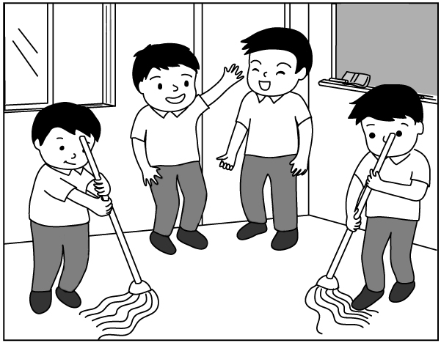
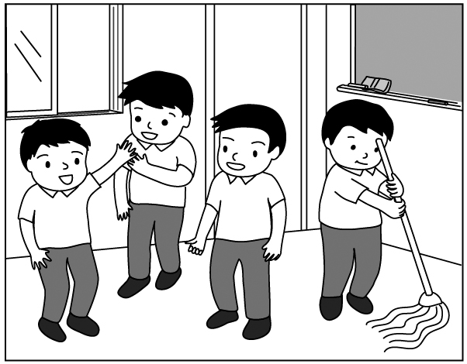
( ) 1. (A) (B) (C)
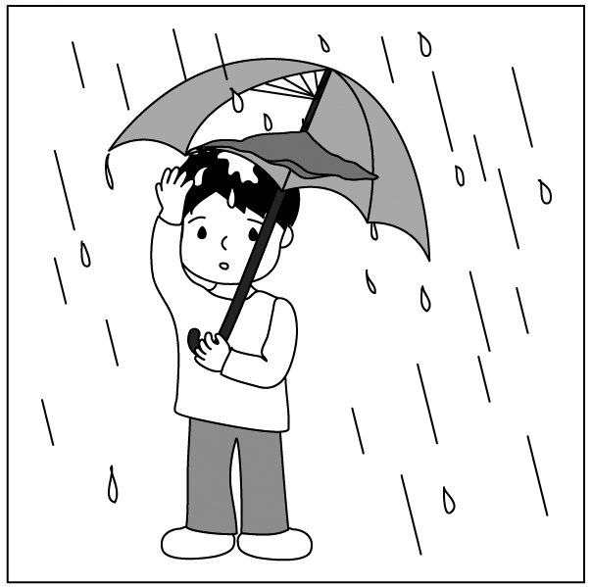
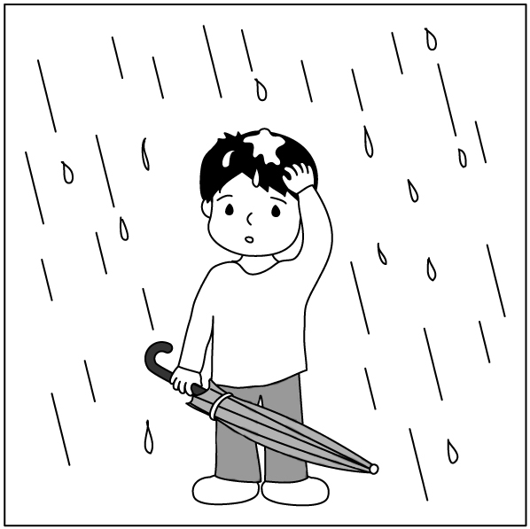
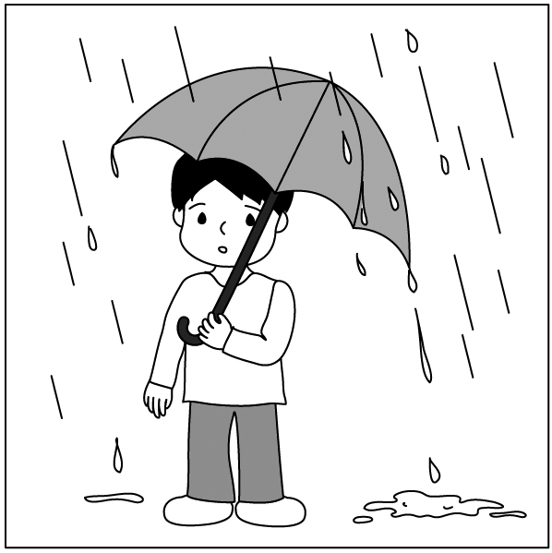
( ) 2. (A) (B) (C)

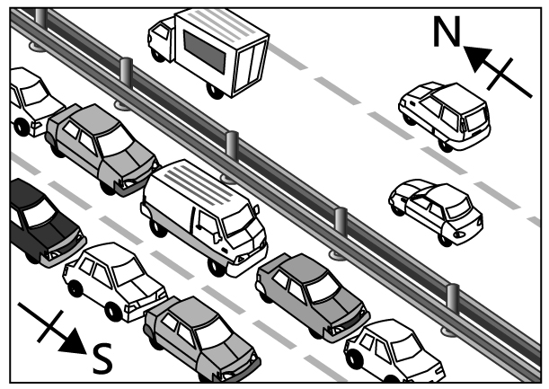
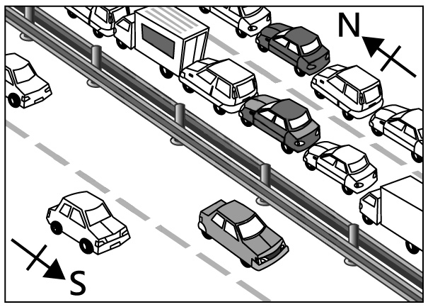
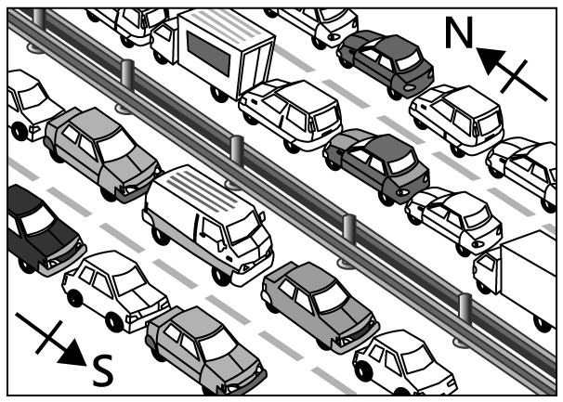
( ) 3. (A) (B) (C)
第二部分：基本問答（第4-10題）
作答說明：每題均有三個選項，請依據所聽到的內容，選出一個最適合的回應，每題播放兩次。
示例題：你會看到
(A) She is talking to the teacher.
(B) She is a student in my class.
(C) She is wearing a beautiful dress.
然後你會聽到……（播音）。依據所播放的內容，正確回應應該選B。
( ) 4. (A) You’re welcome.
(B) Thank you very much.
(C) Nice to meet you.
( ) 5. (A) I like to go fishing.
(B) I like the park.
(C) I like fish.
( ) 6. (A) Did you check your bag?
(B) Isn’t this photo nice?
(C) Where did you find it?
( ) 7. (A) Seldom. I don’t really like it.
(B) Perhaps. Maybe next month.
(C) Great! It’s beautiful up there.

( ) 8. (A) Sorry. I’m not really sure.
(B) Sorry. I can’t tell you the news.
(C) Sorry. You shouldn’t talk there.
( ) 9. (A) Nobody’s home now.
(B) Sounds like a plan.
(C) You never know.
( )10. (A) He’s taller than your sister, right?
(B) Have you seen him these days?
(C) You mean the one with long hair?
第三部分：言談理解（第11-21題）
作答說明：每題均有三個選項，請依據所聽到的對話或短文內容，選出一個最適合的答案，每題播放兩次。
示例題：你會看到
(A) 9:50. | (B) 10:00. | (C) 10:10.
然後你會聽到……（播音）。依據所播放的內容，正確答案應該選B。
( )11. (A) $3,000.
(B) $3,200.
(C) $3,300.
( )12. (A) A doctor.
(B) A reporter.
(C) A teacher.
( )13. (A) At a bookstore.
(B) At a clothes shop.
(C) At a theater.
( )14. (A) They are on a trip together.
(B) They met for the first time.
(C) They went to the same school.
( )15. (A) Get his daughter out of bed.
(B) Make breakfast for his daughter.
(C) Stop his daughter playing online games.
( )16. (A) A restaurant.
(B) A theater.
(C) A train station.
( )17. (A) It still looks like a new car.
(B) The woman will sell it to the man.
(C) There is something wrong with it.
( )18. (A) 6:30.
(B) 7:30.
(C) 8:30.
( )19. (A) In a bakery.
(B) In a market.
(C) In a restaurant.
( )20. (A) It’s helpful.
(B) It’s simple.
(C) It’s stupid.
( )21. (A) He’ll walk there.
(B) He’ll take Bus 108.
(C) He’ll take Bus 260.

