106年國中教育會考
英 語 科 閱讀題本
第一部分：單題（第1-15題，共15題）
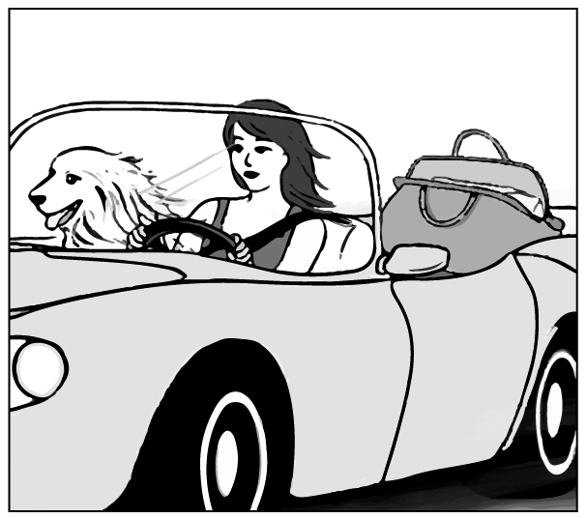
( ) 1. Look at the picture. The dog is sitting ________.
(A) on the bag
(B) next to the woman
(C) inside the bag
(D) between the woman and the bag
【答案】B
【解析】看圖得知狗坐在女人的「旁邊」。故選(B)。(A)在袋子上；(B)在女人旁邊；(C)在袋子裡面；(D)在女人跟袋子之間。
( ) 2. My sister wants to buy a car ________ she doesn’t have enough money.
(A) because (B) but
(C) if (D) or
【答案】B
【解析】我姊姊想要買車，「但是」她沒有足夠的錢。前後文意轉折故選(B)。(A)因為；(B)但是；(C)如果；(D)或者。
( ) 3. Jim always forgets my birthday. He has asked me many times and still can’t ________ it.
(A) answer (B) celebrate
(C) remember (D) understand
【答案】C
【解析】Jim總是忘記我的生日。他已經問過我許多次還是無法「記得」。故選(C)。(A)回答；(B)慶祝；(C)記得；(D)了解。
( ) 4. The little girl was ________ by a truck on her way home and was badly hurt.
(A) hit (B) led
(C) lost (D) paid
【答案】A
【解析】小女孩在回家路上被卡車「撞到」，傷得很嚴重。故選(A)。(A)撞到；(B)帶領；(C)遺失；(D)付帳。
( ) 5. Excuse me. I really need to go now. My kids ________ for me at school.
(A) are waiting
(B) were waiting
(C) wait
(D) waited
【答案】A
【解析】很抱歉，我現在必須離開，我的小孩「正在學校等我」。故選(A)。be動詞＋V-ing表「正在…」。
( ) 6. Amy’s father is very sick. The doctors can do nothing for him, so Amy went to the temple to ________ for him.
(A) care (B) count
(C) look (D) pray
【答案】D
【解析】Amy的父親病得很重。醫生無能為力。所以Amy到廟裡為父親「祈福」。故選(D)。(A)關心；(B)計算；(C)看；(D)祈禱。
( ) 7. I’m glad that my school has students wear ________. I don’t have to worry about what clothes to wear to school.
(A) belts (B) caps
(C) gloves (D) uniforms
【答案】D
【解析】我很高興我們學校讓學生穿「制服」。我不必擔心上學時要穿什麼衣服。故選(D)。(A)皮帶；(B)帽子；(C)手套；(D)制服。
( ) 8. We are surprised that Sally and Ray decided to get married. No one knows ________. They often fight with each other and are unhappy together.
(A) why (B) where
(C) when (D) how
【答案】A
【解析】我們非常驚訝Sally跟Ray要結婚了。沒有人知道「為何」。他們在一起時常常吵架，而且不開心。故選(A)。(A)為何；(B)哪裡；(C)何時；(D)如何。
( ) 9. I don’t think Katie will read any one of the books you’ve picked out for her: ________ look(s) very boring.
(A) it (B) one (C) some (D) they
【答案】D
【解析】我不認為Katie會讀任何一本你為她挑選的書。「它們」看起來都很無聊。書本為複數，用代名詞「they」代替。故選(D)。
( )10. Jenny’s bag is very heavy because ________ filled with toy cars.
(A) it is
(B) they are
(C) there is
(D) there are
【答案】A
【解析】Jenny的袋子很重因為塞滿了玩具車。用it代替主詞Jenny’s bag。故選(A)。
( )11. ________ a map with you when you go to a place for the first time.
(A) Have taken (B) Take
(C) Taking (D) To take
【答案】B
【解析】祈使句以原形動詞開頭。故選(B)。
( )12. The weather ________ rainy and cloudy in the last few days. I hope the sun will come out soon.
(A) has been (B) had been
(C) will be (D) would be
【答案】A
【解析】第二句提到「希望太陽趕快露臉」，表示從過去這幾天到現在一直陰雨不斷。故選(A)。現在完成式have/has +過去分詞，表示從以前持續發生到現在。
( )13. All the excuses Nick made ________ a lot about how much he hates to do the job.
(A) say (B) saying
(C) which say (D) to say
【答案】A
【解析】主詞為All the excuses Nick made（Nick所說的藉口），因為為複數，所以動詞以複數動詞呈現，故選(A)。
( )14. Sabine walks so ________ in the apartment that sometimes you don’t even know she’s just passed by. You wonder if her feet ever touch the floor.
(A) freely (B) lightly
(C) shyly (D) slowly
【答案】B
【解析】由後段文意提到「甚至不知道她經過」推測Sabine走路是「輕輕的」。故選(B)。
( )15. In the past, people thought it was a ________ idea to send e-mails and read news online, but now it is part of our everyday life.
(A) simple (B) popular
(C) good (D) fresh
【答案】D
【解析】由後段文意提到「但是現在是生活的一部分」推測在過去寄電子郵件跟閱讀網路新聞是「新奇的」。故選(D)。(A)簡單的；(B)受歡迎的；(C)好的；(D)新奇的。
第二部分：題組（第16-41題，共26題）
（16-18）


Do you have some books you don’t want?
Your old love may be someone’s new favorite.
Bring one book to the Town Library & get another one home for free!
When & How:
March 2 - March 14 Bring one book for one book festival card.
March 16 - March 31 Bring one card for one book you like to read.
What books:

All kinds of books EXCEPT school books, comic books, and dictionaries.
Notice:
○Your book must be in good shape, without any page missing.
○Your book must be clean, and nothing is written on it.
Want to know more? Please call 1234-5678. (We are closed on Mondays.)
-Town Library-
( )16. What is the book festival for?
(A) Selling second-hand books.
(B) Telling people how to choose books.
(C) Inviting people to change books with each other.
(D) Knowing what kinds of books are the most popular.
【答案】C
【解析】海報開頭提到「有沒有一些不想要的書？你的舊書可能是別人想要的新書，帶一本書來城市圖書館就可以免費換另一本回家」看來，這是一個舊書交換的活動。故選(C)。
( )17. Sonja is busy packing some books for the book festival. Which is most likely one of them?
(A) An old dictionary of medicine.
(B) A book of short stories in English.
(C) A picture book with her own notes.
(D) A workbook she used in her math class.
 likely 可能
【答案】B
【解析】海報中提到想要交換書的種類不能是：學校書籍、漫畫及字典。而在注意事項也提到「保持書的完整、不能破損、乾淨、不能在上面做任何筆記」，因此符合這些條件的只有(B)。
( )18. Look at the calendar. If Sean has a book festival card, when can he
use it?
(A) March 3.
(B) March 14.
(C) March 23.
(D) March 29.
calendar 月曆
【答案】C
【解析】海報中提到3/16～3/31為拿換書卡來選喜歡的書，但不能是星期一，因為星期一圖書館休館，因此Sean可以使用這張卡的時間只有(C)3/23。
（19-21）
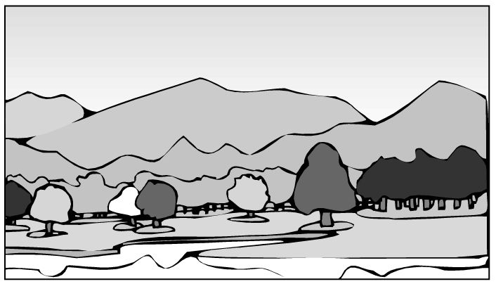
I had a horrendous experience last Saturday.
That day, my family went camping near a big lake. While my parents were preparing dinner, my brother and I were playing by the lake. A dirty man appeared from somewhere, and his face was half covered by his hair. He walked to us and asked for some water.
while 當…之時
When I gave him water, the bag he carried dropped, and things inside fell out on the grass. I saw a rope, a knife, and a baseball bat. The strangest thing was that there were also a woman’s shoe and a ring, and I’m sure they were not his. The man quickly put all his things back in the bag and looked at us angrily. At that moment, the picture of a man the police was looking for came to my mind. He was the crazy killer! I was so afraid that I could not move at all.
Luckily, before he could get any closer, my mom shouted from far away, and the man hurried off into the dark.

( )19. What happened in the story?
(A) A killer was caught by the police.
(B) The writer’s family invited a stranger to dinner.
(C) The writer’s brother ran to their parents for help.
(D) A man ran away after he heard the writer’s mother’s voice.
【答案】D
【解析】文章最後一段提到：在陌生人更靠近作者前，陌生人聽到作者的母親從遠處大喊而迅速消失在黑暗中，故選(D)。
( )20. What can we learn about the writer and the man with a bag?
(A) The man attacked the writer.
(B) The writer followed the man into the dark.
(C) The writer did not find out who the man was in the end.
(D) The man did not want the writer to see things in his bag.
【答案】D
【解析】從文章第三段第四句敘述陌生人十分快速地把掉落的物品收回去袋子並生氣地看著作者的動作推測，陌生人不甚願意作者看到這些東西。故選(D)。
( )21. How do people feel when they experience something horrendous?
(A) Angry.
(B) Sad.
(C) Scared.
(D) Tired.
【答案】C
【解析】從文章作者敘述看到疑似殺人犯的陌生人經過，當時心裡應該是「害怕的」。故選(C)。
（22-24）
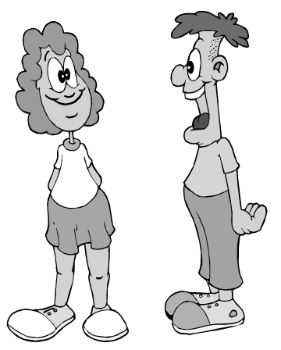
Ruth: I’ve got two tickets for a football game. The Lions vs. the Sharks, front-row seats, next Saturday. Interested? You can take Jessica to the game.
book 訂位
Nate: How did you get the tickets?! They were all sold out months ago!
Ruth: And a table for two at Leeds.
Nate: Leeds?! But I called them yesterday and they said they were all booked for the year!
Ruth: Now it’s yours. You and Jessica can have a lovely dinner there after the game.
Nate: Wait a second. This is just not like you. What’s the catch?
Ruth: Well, you know this Friday I’m leaving for my vacation in London, and....
Nate: And what?
Ruth: And I was thinking if Charlie could stay with you next week.
Nate: The whole week?!
Ruth: Please! I can’t just leave him in my apartment.
Nate: You know I hate that stupid dog! And he hates me too.
Ruth: Please! You’re my last hope.
Nate: I need to think about it.
Ruth: OK, but not too long.
( )22. What does the catch mean in the dialogue?
(A) A plan that starts well but ends badly.
(B) A fact that everyone knows but never talks about.
(C) A problem that is hidden behind something good.
(D) An action that is right in one way but wrong in another.
【答案】C
【解析】從對話一開始Nate認為Ruth所拿到的美式足球賽門票以及餐廳座位都是十分難以取得，但Ruth卻要把這些給他跟Jessica的行為並不像Ruth 平常會做的，因此回應的語氣應該是質疑的。所以What’s the catch?有懷疑背後有什麼詭計的意思。故選(C)。
( )23. What does it mean in the dialogue?
(A) Taking care of Charlie.
(B) Having dinner with Jessica.
(C) Going to the football game.
(D) Going to London for vacation.
【答案】A
【解析】對話倒數第七行Ruth提出她的需求：請Nate幫忙照顧她的狗Charlie一個星期。而Nate需要再想想。故it代表的是「照顧狗」這件事。 故選(A)。
( )24. What do we know from the dialogue?
(A) Ruth will go to London next Saturday.
(B) Ruth had trouble booking a hotel room in London.
(C) Nate is the first person that Ruth thought of for help.
(D) Nate is surprised that Ruth was able to book a table at Leeds.
【答案】D
【解析】文章開頭提到Nate自己都無法預約訂到Leeds餐廳，因此對於Ruth能夠訂到座位感到十分驚訝，故選(D)。

（25-26）
drunk 酒醉的 law 法律
When you need to see a doctor, surely you will want to see a good one. But there is one important thing you may never have thought about: Has your doctor rested enough?

Doctors in our country often have to work 34 hours or longer without sleep. Most of them work 104 hours a week, and some even 150. (There are only 168 hours a week!) One report said that a doctor who works such long hours cannot think more clearly than a drunk driver. Another found that doctors who sleep 5.8 fewer hours than the week before might make 22% more serious mistakes. Surely no one wants to get in a car that is driven by a drunk driver. So, how safe would you feel when you are under the care of a tired doctor?

Sadly this problem has been around for a long time. There are no laws about it yet and hospital bosses don’t look like they care either. And that is why we doctors are asking you to join us on the street this Sunday. Fight together with us on the street so we can fight better for your life in the hospital.

 Time: 1 p.m. May 2nd  Place: City Hospital Square

( )25. What is this reading for?
(A) Telling people rules about hospital visits.
(B) Getting people to stand up and speak for doctors.
(C) Telling people how to find a good doctor for themselves.
(D) Getting doctors to share their experiences in saving lives.
【答案】B
【解析】文章第二段主要提到醫生工作時間過長，休息時間少，所以病人如何能在如此疲憊的醫療品質下得到好的照顧？第三段提到希望大家一起為醫生站出來，因為醫生有良好的休息，病人醫療品質才能獲得保證。故選(B)為醫生發聲。
( )26. What does this problem mean in the reading?
(A) Doctors’ long working hours.
(B) Doctors’ problems with nurses.
(C) Doctors do not see enough people a day.
(D) Doctors are not paid enough for their work.
【答案】A
【解析】從第二段說明醫生長達34小時甚至更久未曾休息；或者一個星期工時長達104～150小時看來，表達出「這個問題」為「工時過長」。故選(A)。
（27-28）
service charge 手續費

Have you ever seen a pumpkin that looks like a nose or an apple that looks like a funny face? They may not look great, but they taste just as good as the pretty ones. These strange-looking fruit and vegetables are called “seconds.” About 20-40% of what farmers grow is not so beautiful. Sadly, these “seconds” seldom arrive at your table, but often go straight into the trash can. Why? It’s because supermarkets don’t want to buy them from farmers—they believe their shoppers only love beautiful things. Because of these “seconds,” some farmers lose a lot of money.

Wonky Markt wishes to change this. We’re helping sell these “seconds.” Farmers can save them from the trash can, and you can get them at a lower price.

1. NT$250 a box.
2. You can choose as many as six kinds of fruit and vegetables a box.
3. Service charge: NT$50 a box.
4. No service charge if order is over NT$1,000.

Send us photos of your delicious dishes that are made with our “seconds” to oneandonly@wonkymarkt.com, and you may win our cookbook.

( )27. What does Wonky Markt care about?
(A) Supermarkets often sell “seconds” at a lower price.
(B) Farmers don’t know how to grow fewer “seconds.”
(C) “Seconds” are thrown away because of how they look.
(D) People don’t know much about picking fresh “seconds.”
【答案】C
【解析】文章第二段提出Wonky Markt想要改變「這個狀況」。狀況可從第一段內容看出。第一段點出農作物如果不漂亮，超市就不進這些貨，因為他們相信消費者不會購買這樣不好看的農產品，如此農夫就會損失許多錢。因此Wonky Markt關心這些「賣相不好的農作物被丟棄」一事。故選(C)。
( )28. What do we know about buying the “seconds” from Wonky Markt?
(A) You can save 20-40% if you shop for a second time.
(B) If you buy three boxes, you will need to pay NT$900.
(C) You can choose not only their size but also their shape.
(D) To win the cookbook, you need to buy at least six boxes.
【答案】B
【解析】Wonky Markt以以下方式販賣這些「賣相不好」農作物：一箱250元，可選六種蔬菜水果，手續費一箱50元，購買超過1,000元免手續費。故選(B)買三箱要付900元（250×3＋50×3=900）。

（29-30）
Below is the news about Dashing Shuttle’s bus line changes.
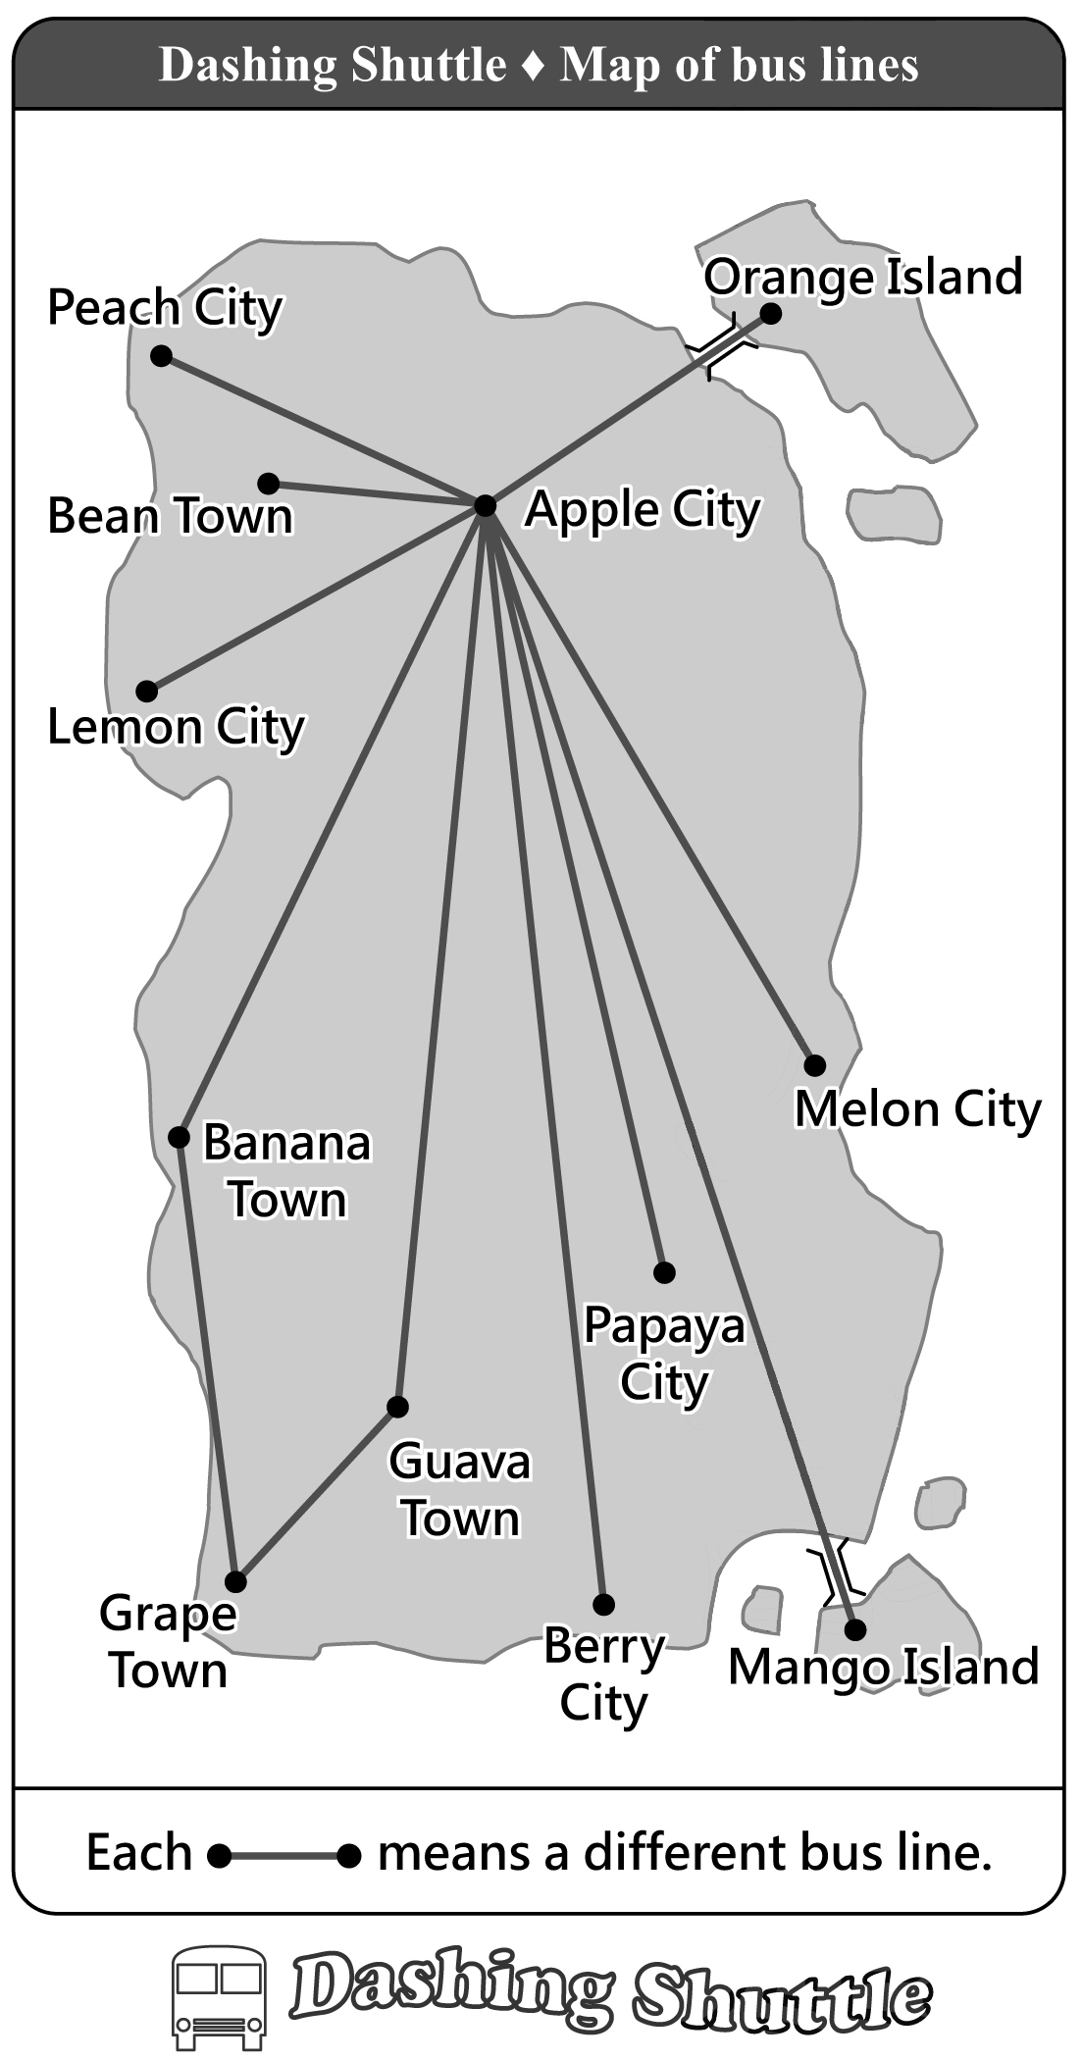 | 1. Great news for people who travel between Apple City and Peach City! From July 1, we have three more buses to Peach City every day.
 | 2. A trip from Apple City to Lemon City or Berry City will take less time. From July 1, you can go from Apple City to each of the two cities without changing buses.
 | 3. Dashing Shuttle is the first in the country to open a bus line between Apple City and Orange Island. From July 1, our bus will take you to Orange Island every day!
 | 4. Our bus line between Apple City and Grape Town will stop running on June 30. From July 1, changing buses at Guava Town or Banana Town will be the best way to travel.
 | 5. From July 1, our bus runs from Apple City to Mango Island three times a day. You don’t need to change buses at Melon City anymore.

( )29. What can we learn from the reading?
(A) No buses go from Apple City to Orange Island before the bus line changes.
(B) Before July 1, those who want to visit Mango Island have to take a bus at Berry City.
(C) Traveling from Apple City to Grape Town will take less time after the bus line changes.
(D) Before July 1, Dashing Shuttle does not have buses from Apple City to Peach City.
【答案】A
【解析】文章中第三點敘述提到：Dashing接駁是國內第一個提供從Apple城市到Orange島的接駁車，從七月一日起提供載客服務。故選(A)。
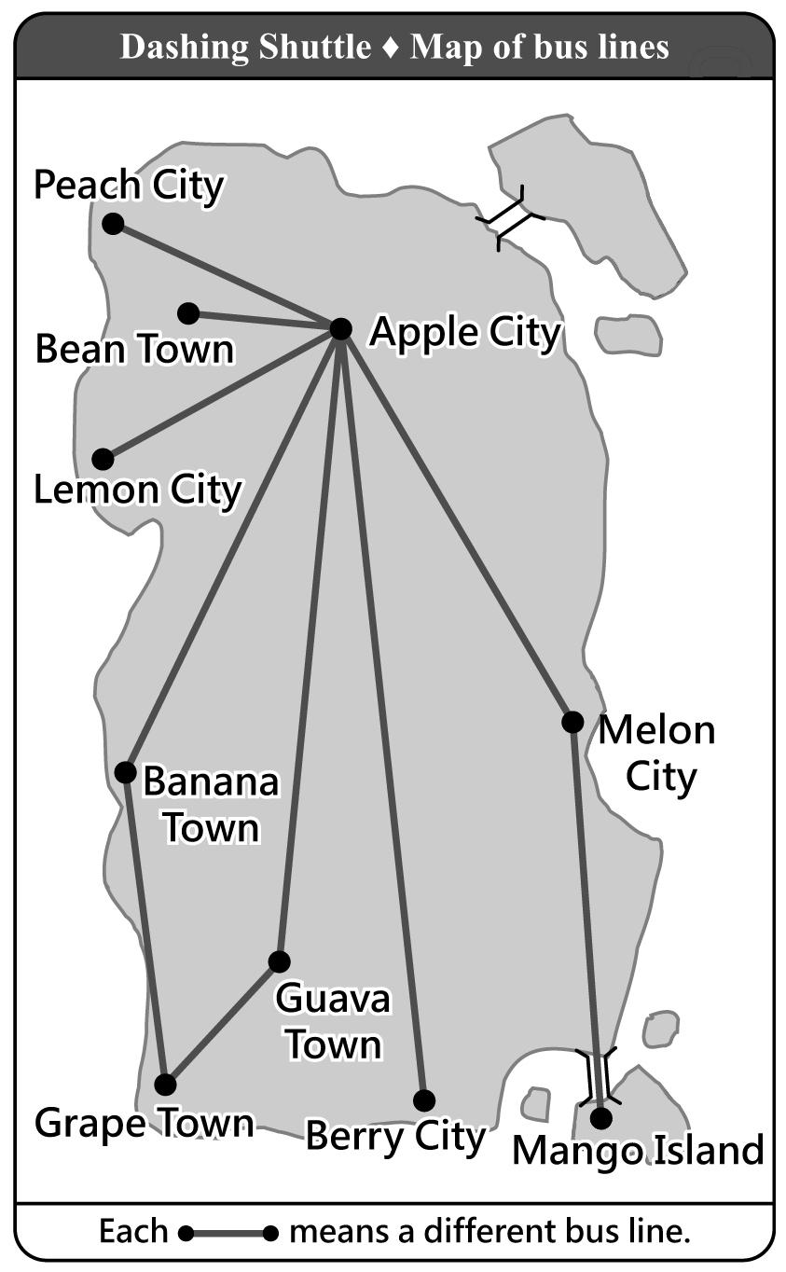
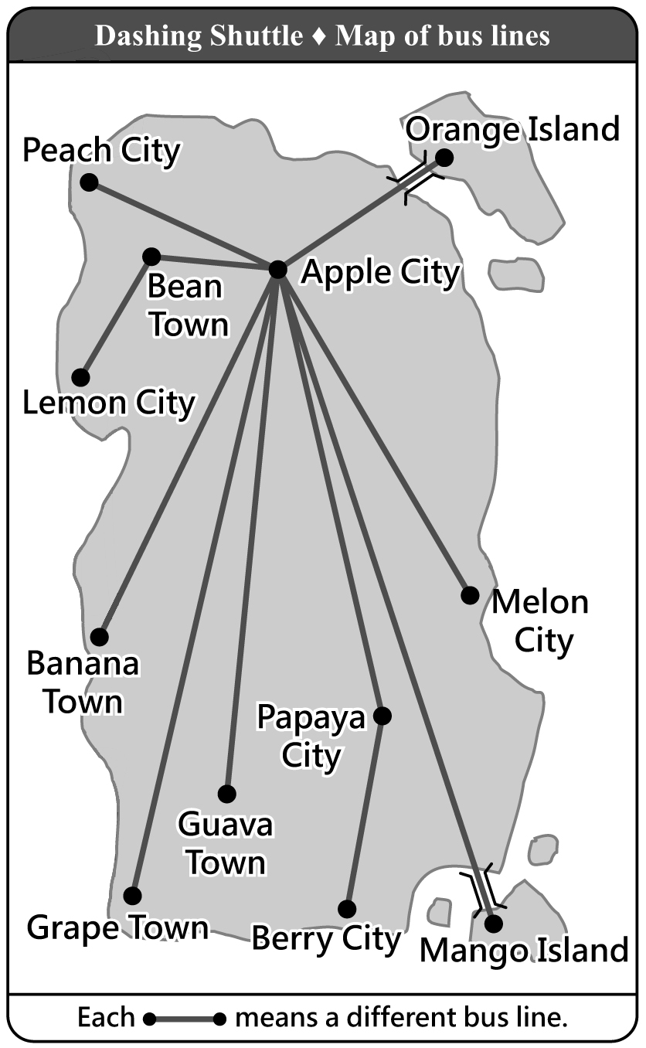
( )30. Which is most likely Dashing Shuttle’s map of bus lines before July 1?
(A) (B)
likely 可能
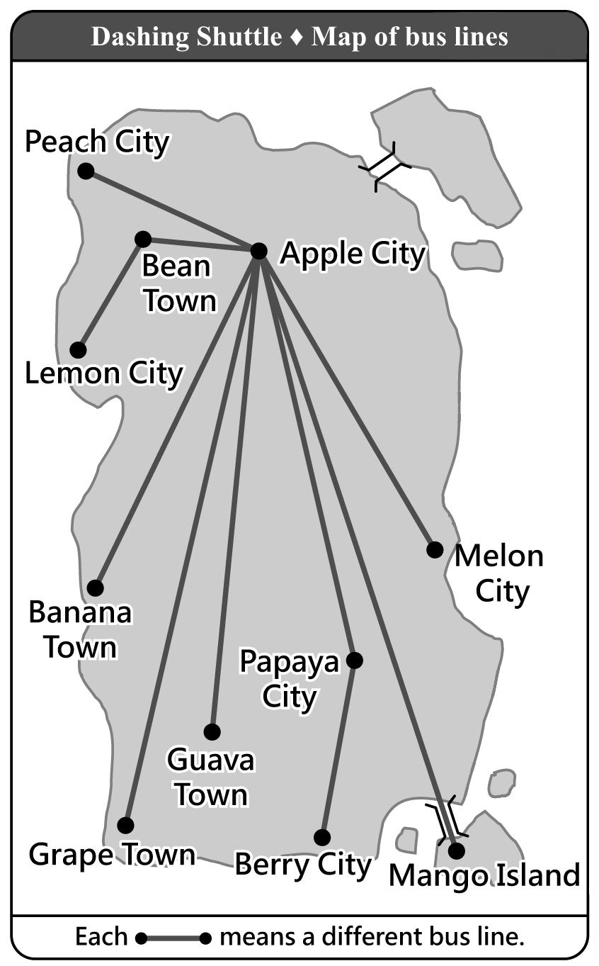
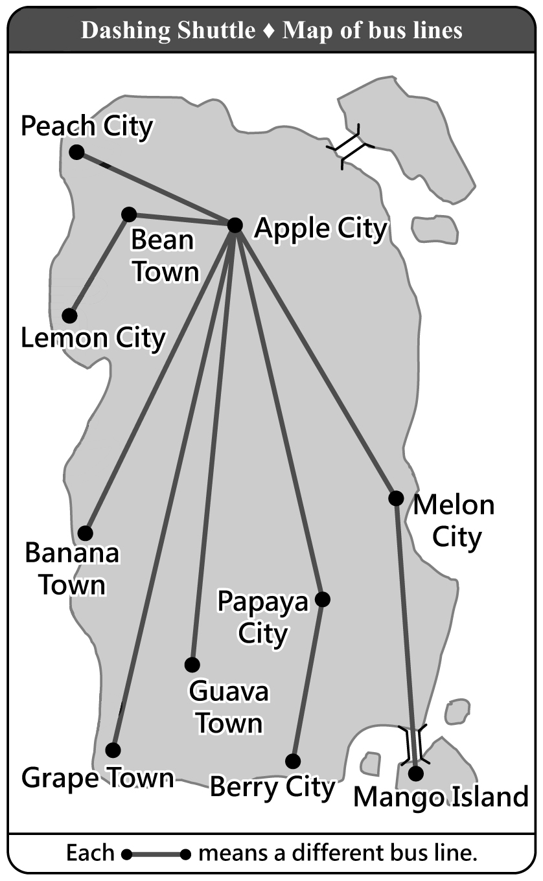
(C) (D)
【答案】D
【解析】從第五點敘述來判斷七月一日前的通車圖應該是(D)。理由為：第二點：從Apple城市到Lemon城市或Berry城市時間縮短且不需換車。第三點：以往沒有通往Orange島的車。第五點：開通直達到Mango島的車，不需從Melon城市轉車。

（31-33）
Cinema Times
June 5th, 2005
Thanks to globalization, we get to see movies from around the world. If anyone should feel most excited about globalization, it is US movie makers. A study in 2001 shows that, for every 100 people who go to the theater, 85 see US movies. This may be good news for US movie makers, but not for those in other countries.
Chart 1 shows the percentages (%) of US movies in five countries in 1984 and in 2001; Chart 2 shows the percentages (%) of domestic movies in the five countries in 1984 and in 2001. In Chart 1, we can see that US movies have been popular in foreign markets. In Chart 2, we can see that domestic movies in the five countries are not doing well in their domestic market. The falling market for domestic movies may be a serious problem, but there is something more important. When people welcome US movies with open arms, they in fact also say yes to the American way of thinking. Some people in these countries worry that what is lost may not just be their domestic market for domestic movies, but also their own way of thinking that has been passed down from parents to children.
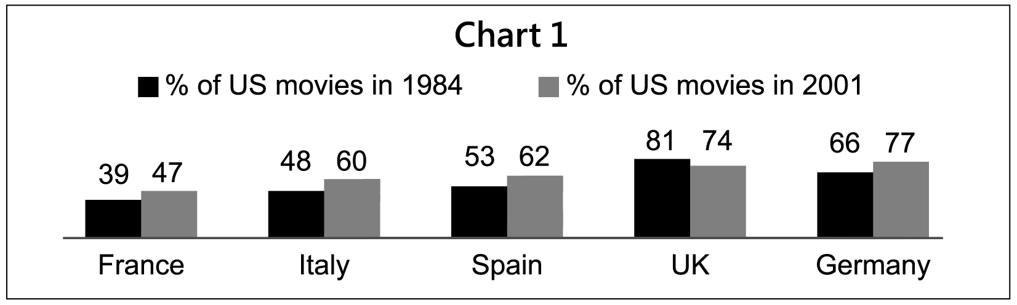
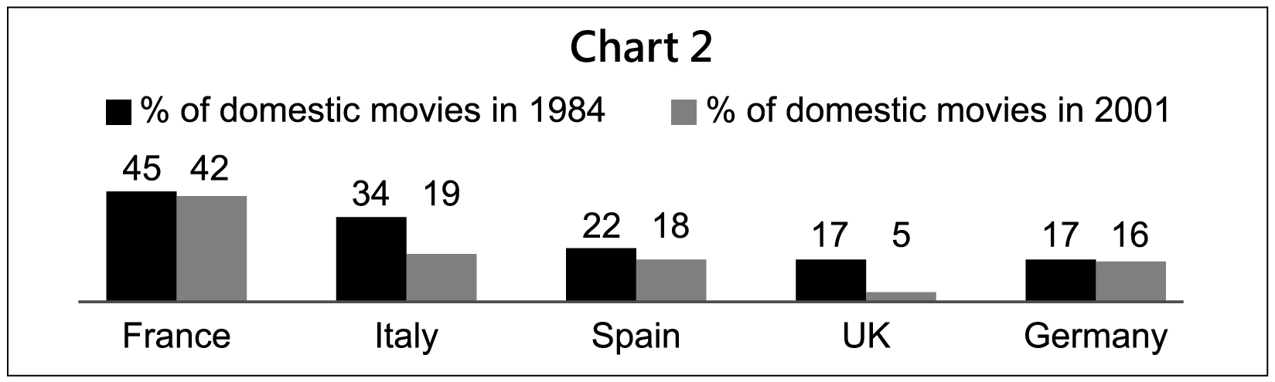
globalization 全球化 domestic 當地的；國產的；本國的

( )31. What does the report say about globalization’s influence on the movie world?
(A) It has changed the way of making movies.
(B) It has changed a country’s domestic market for movies.
(C) It has brought together movie makers from around the world.
(D) It has helped US movies make more money abroad than in the US.
influence 影響
【答案】B
【解析】文章第二段提到在1984年及2001年，五個國家中對於美製電影接受比例呈現成長，相對國內自製電影卻呈現衰退現象，故選(B)。
( )32. What can we learn from the report?
(A) The American way of thinking may be changed when it is brought to other countries.
(B) More and more people are asking their country to help their domestic movie business.
(C) US movies are popular in foreign markets because English is spoken in many countries.
(D) The fact that US movies are popular may mean the American way of thinking is popular.
【答案】D
【解析】文章第二段倒數第二句提出隱憂：當美製電影大受國人喜愛時，代表國人也接受美式的思考方式，故選(D)。
( )33. From the charts, which is true?
(A) The percentage (%) of US movies has changed the least in Spain.
(B) In each of the five countries, the percentage (%) of domestic movies has fallen.
(C) Of all five countries, UK’s domestic movies have the smallest drop in percentage (%).
(D) When the percentage (%) of domestic movies drops, the percentage of US movies rises.
【答案】B
【解析】從圖表二得知：每個國家的國內電影產業都是呈現衰退現象，故選(B)。

（34-37）
Jerry Stevens has been unhappy these months. He a proud businessman of a successful shaved ice shop. His highest sales numbers were 1,899 plates a week; people called him “Ice King.” But all this changed when the cookie shop across the street started selling ice cream cookies. It took away half of his business.
And when Dan, his dead sister’s only son, came to work for him.
Dan was a nice young man with a simple mind, too simple, maybe. He always let people try some shaved ice for free, but he never learned to see when “some” became “too much.” Many people came, but few bought. When the sales did not grow with the heat, Jerry started to worry. He wanted to send Dan home. But how could he? Dan had no family except him.
Then, one day, . And it was from across the street. The cookie shop a clerk. For Jerry, it was a great chance to get Dan out of his store without sending him home. After taking the shopkeeper to several nice dinners, Jerry got Dan the job.
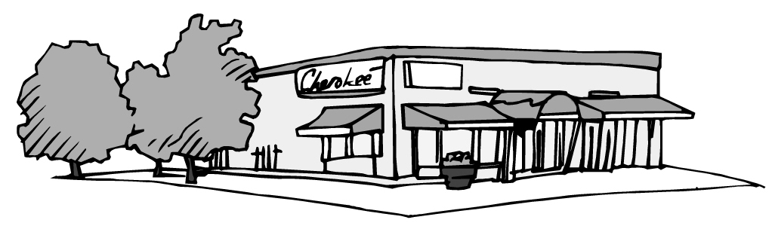
Now Jerry could finally try and save his store. And maybe Dan would help by sending him
a few people who are thirsty from eating too many cookies.
shaved ice 刨冰

( )34. (A) is
(B) has been
(C) used to be
(D) was going to be
【答案】C
【解析】文章第一段第一行提到這幾個月來，Jerry一直不開心。但後句敘述是對自己刨冰事業成功引以為榮的商人看來，是在描述過往經驗，故選(C) used to be... 曾經…。
( )35. (A) things didn’t get better
(B) he was ready to give up
(C) the sales of shaved ice finally started to rise
(D) the cookie shop was not successful for long
【答案】A
【解析】第二段開頭提到Dan來幫忙，應該是希望生意起死回生，但是描述的情況看來「並未變好」，故選(A)。
( )36. (A) his only hope died
(B) good news arrived
(C) worse trouble came
(D) the hard time passed
【答案】B
【解析】從文章第四段第四句提到「對於Jerry而言，這是一個能夠讓Dan不要繼續留在他的店裡又不用把他趕走的好機會」看來，應該「是個好消息」傳來，故選(B)。
( )37. (A) used to look for
(B) has looked for
(C) was looking for
(D) had looked for
【答案】C
【解析】從第四段最後一句，Jerry請客好幾次才讓Dan得到這份工作的敘述得知，餅乾商店應該「正在徵人」，故選(C) was looking for。

（38-41）
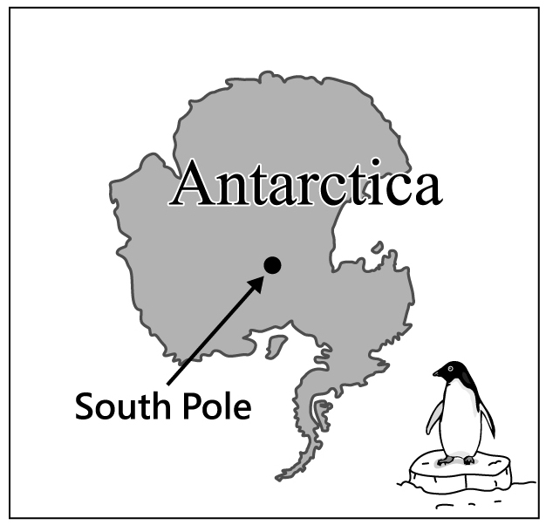
Englishman Robert Scott is known for leading two trips to Antarctica. The first one made him a star; the second .
After his first successful trip, Scott decided to be the first person to stand on the South Pole. However, . He would be in a race with Roald Amundsen, from Norway. Both left their countries by ship in June of 1910 and arrived in Antarctica in January of 1911.
About ten months later, both teams started their trips down to the South Pole. . Amundsen’s team used dogs, and Scott’s team used horses. Because horses weren’t good at traveling on snow, it took Scott’s team 77 days to arrive at the South Pole. They got there on January 17, 1912, and were surprised to find that Amundsen was ahead of them. The news hit Scott very hard, but what he didn’t know was that . His team began their long trip home with broken hearts. After days of terrible weather and little food, Scott lost his men one after another, and he himself was the last one to meet the end of his life. No one on his team lived to go back home and tell their story. It was only learned through Scott’s diary.
( )38. (A) hurt his health
(B) opened his eyes
(C) cost him his life
(D) made his dream come true
【答案】C
【解析】從文章最後一句：事情經過是從Scott的日記得知，看來第二趟到南極洲的旅程並沒有讓Scott平安回家，故選(C)。
( )39. (A) he didn’t want to take this trip with others
(B) he wasn’t the only one who had this dream
(C) he wouldn’t let anyone else take his prize away
(D) he couldn’t miss the chance to make his country proud
【答案】B
【解析】從第二段提到尚有另一組探險隊競爭前往南極得知，Scott「並非唯一夢想登陸南極」的人。故選(B)。
( )40. (A) And Scott used a popular way for his men to travel fast
(B) But there were problems to deal with before they traveled
(C) But Amundsen didn’t know better about animals than Scott
(D) And their ways of traveling decided which team would win
【答案】D
【解析】第三段後面敘述提到對手選擇狗而Scott這隊選擇馬，但馬並不擅長在雪地行走，因此對手大幅領先Scott得知選擇的交通方式決定輸贏。故選(D)。
( )41. (A) there was still hope
(B) no one ever believed him
(C) the worst had not come yet
(D) Amundsen had not been honest
【答案】C
【解析】對手大幅領先的消息雖然打擊Scott，但是Scott並不知道。由後文敘述隊友一個個死亡的文意判斷Scott並不知道「更慘的事情還沒到來」。故選(C)。
英 語 科 聽力題本
第一部分：辨識句意（第1-3題）
作答說明：每題均有三張圖片，請依據所聽到的句子，選出符合描述的圖片，每題播放兩次。
示例題：你會看到
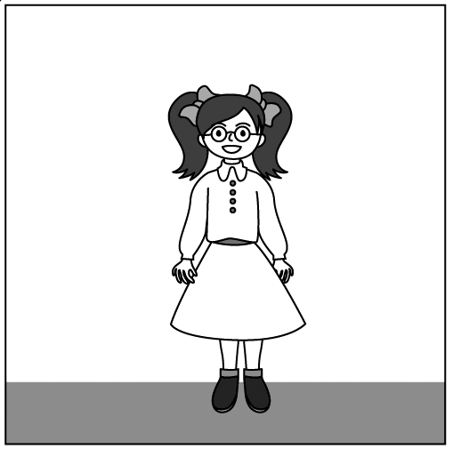  (A) | 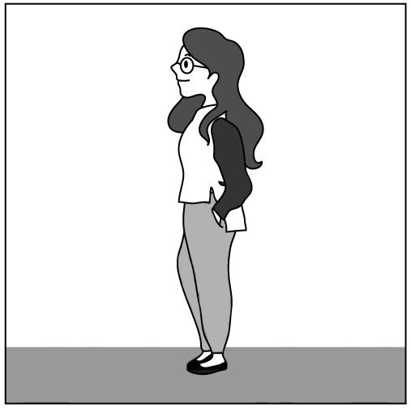  (B) | 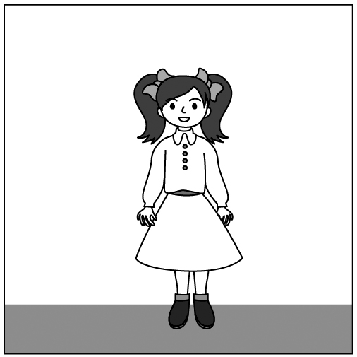  (C)
然後你會聽到……（播音）。依據所播放的內容，正確答案應該選A。
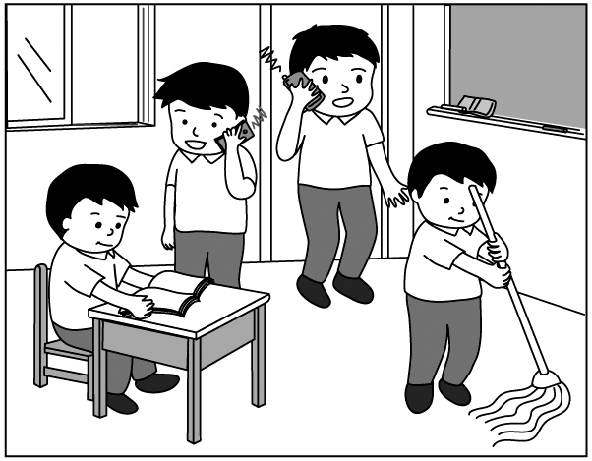
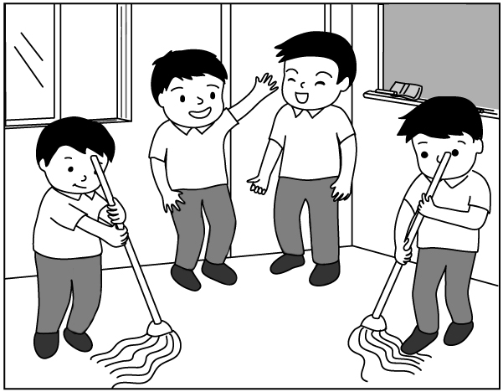
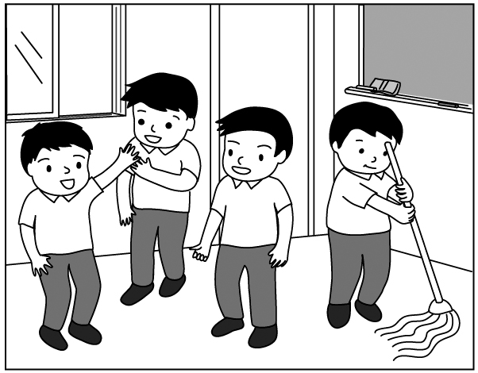
( ) 1. (A) (B) (C)
【答案】A
【解析】One of the students is mopping the floor, and the others are talking.
（其中一位學生正在拖地，而其他學生正在講話。）
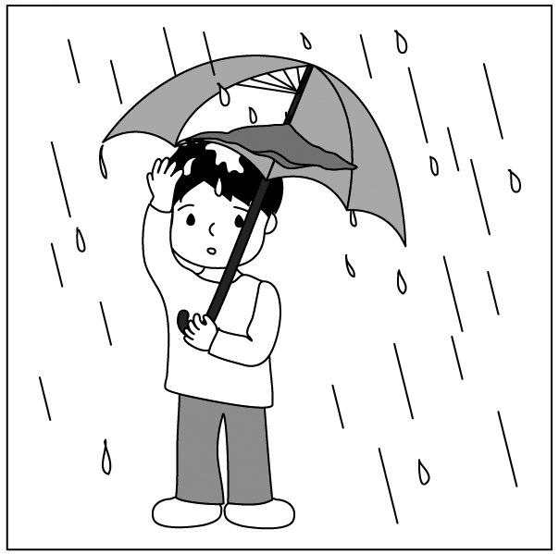
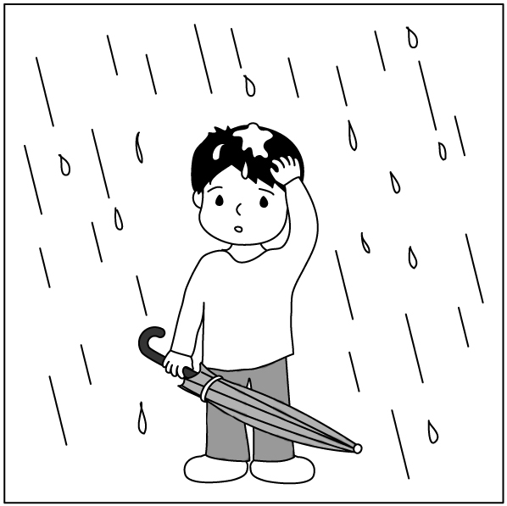
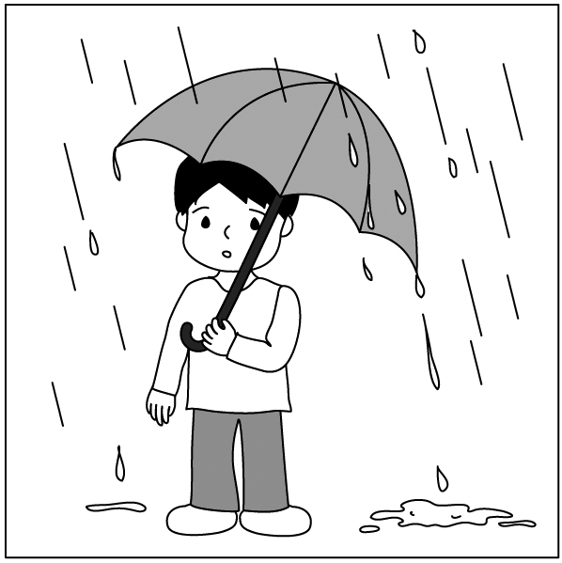
( ) 2. (A) (B) (C)
【答案】C
【解析】The boy’s holding a broken umbrella, and the rain keeps falling through the hole onto his head.
（那個男孩正拿著一把壞掉的雨傘，而雨一直穿過破洞滴在他的頭上。）
( ) 3. (A) (B) (C)
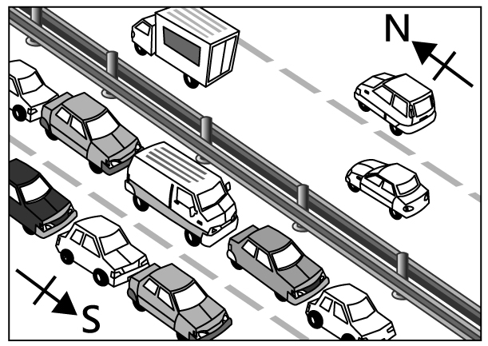
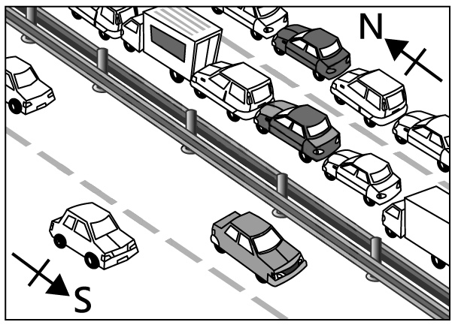
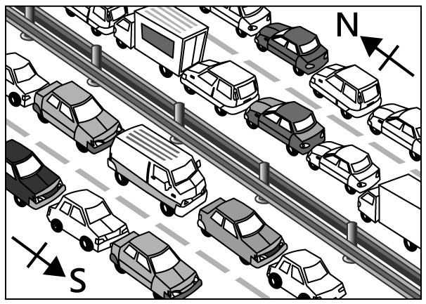
【答案】B
【解析】There are a lot of cars going up north, but there are few cars going down south.
（有很多車往北邊行駛，但往南開的車很少。）

第二部分：基本問答（第4-10題）
作答說明：每題均有三個選項，請依據所聽到的內容，選出一個最適合的回應，每題播放兩次。
示例題：你會看到
(A) She is talking to the teacher.
(B) She is a student in my class.
(C) She is wearing a beautiful dress.
然後你會聽到……（播音）。依據所播放的內容，正確回應應該選B。
( ) 4. (A) You’re welcome.
(B) Thank you very much.
(C) Nice to meet you.
【答案】B
【解析】Happy Birthday, Rachel. Here’s a CD of your favorite singer.
（Rachel，生日快樂。這是妳最愛的歌手的CD。）
( ) 5. (A) I like to go fishing.
(B) I like the park.
(C) I like fish.
【答案】C
【解析】Which do you like, pork or fish?
（你喜歡哪個，豬肉還是魚肉？）
( ) 6. (A) Did you check your bag?
(B) Isn’t this photo nice?
(C) Where did you find it?
【答案】A
【解析】Oh, no! I can’t find my camera.
（喔，不！我找不到我的相機。）

( ) 7. (A) Seldom. I don’t really like it.
(B) Perhaps. Maybe next month.
(C) Great! It’s beautiful up there.
【答案】A
【解析】How often do you go mountain climbing?
（你多常去爬山？）

( ) 8. (A) Sorry. I’m not really sure.
(B) Sorry. I can’t tell you the news.
(C) Sorry. You shouldn’t talk there.
【答案】A
【解析】Excuse me. Can you tell me where the library is?
（不好意思。你可以告訴我圖書館在哪嗎？）

( ) 9. (A) Nobody’s home now.
(B) Sounds like a plan.
(C) You never know.
【答案】B
【解析】The weather is so nice today. Let’s go for a swim this afternoon.
（今天天氣很好。我們今天下午去游泳吧。）

( )10. (A) He’s taller than your sister, right?
(B) Have you seen him these days?
(C) You mean the one with long hair?
【答案】C
【解析】Who’s the boy talking to your sister?
（那個正在跟你姊姊講話的男孩是誰？）
第三部分：言談理解（第11-21題）
作答說明：每題均有三個選項，請依據所聽到的對話或短文內容，選出一個最適合的答案，每題播放兩次。
示例題：你會看到
(A) 9:50. | (B) 10:00. | (C) 10:10.
然後你會聽到……（播音）。依據所播放的內容，正確答案應該選B。
( )11. (A) $3,000.
(B) $3,200.
(C) $3,300.
【答案】B
【解析】 W: How much is this sweater?
（這件毛衣多少錢？）
M: It’s three thousand five hundred dollars.
（三千五百元。）
W: What? That’s too much.
（什麼？這太貴了。）
M: Well, it’s handmade, and you seldom see this kind of sweater. This is the last one we have.
（喔，這是手作的，而且你很少會看到這種毛衣。這是我們的最後一件了。）
W: I’ll give you three thousand.
（我可以給你三千元。）
M: Not possible. Three thousand three hundred. Can’t be lower.
（不可能。三千三百元。不能再低了。）
W: Three thousand two hundred?
（三千兩百元呢？）
M: All right, then.
（那好吧。）
W: OK, I’ll take it.
（好，我就要這件了。）
Q: How much is the woman paying for the sweater?
（這女子要付多少錢來買這件毛衣？）
( )12. (A) A doctor.
(B) A reporter.
(C) A teacher.
【答案】A
【解析】 W: Hello! What can I do for you today?
（哈囉！今天需要我幫你什麼嗎？）
M: I fell down the stairs at school this morning and hurt my left foot.
（我今早從學校樓梯上摔下來，弄傷了我的左腳。）
W: Hmm, let’s have a look. Does this hurt?
（嗯，我看看。這樣會痛嗎？）
M: Ouch! Yeah! It surely does.
（噢！會！當然痛。）
W: OK. Put some ice on your foot for 10 to 15 minutes, several times a day. And try to rest as much as possible. You need to keep the foot up. Come back in two days, so I can check it again.
（好。一天冰敷幾次，每次十到十五分鐘，盡可能休息。你需要把腳抬高。兩天後再回診，我再幫你檢查一次。）
Q: What is the woman?
（這女子的職業為何？）

( )13. (A) At a bookstore.
(B) At a clothes shop.
(C) At a theater.
【答案】B
【解析】 W: Hey. Let’s have a look inside.
（嘿。我們到裡面看看。）
M: Lil’s Pieces? Oh, isn’t this Lily Weber’s Shop? My favorite movie star. She’s also a great writer. I’ve read two of her books.
（Lil’s Pieces這間嗎？喔，這不是Lily Weber的店嗎？她是我最愛的電影明星。她也是一個很棒的作家。我讀過她的兩本書。）
W: Yap. That’s her. I’m also a big fan of hers. Oh, look at these skirts and shirts.
（是啊。就是她。我也是她的書迷。噢，你看這些裙子和襯衫。）
M: Do you want to try them on?
（妳想要試穿看看嗎？）
Q: Where are the man and woman?
（這男子和女子在哪裡？）
( )14. (A) They are on a trip together.
(B) They met for the first time.
(C) They went to the same school.
【答案】C
【解析】 M: Sandy?
（Sandy？）
W: Ugh, do I know you?
（呃，我認識你嗎？）
M: Mike Black! Remember? We were in Mrs. Sloane’s class for a year.
（我是Mike Black！記得嗎？我們在Mrs. Sloane的班上同班一年。）
W: Ugh, oh, yeah! Wow! You are so different. What are you doing in London?
（呃，喔，對！哇！你變得很不一樣。你在倫敦做什麼？）
M: I’m on a business trip. And you?
（我來出差。妳呢？）
W: I’m studying here.
（我在這裡讀書。）
Q: What do we know about the man and the woman?
（我們可得知有關這男子和女子的什麼事？）

( )15. (A) Get his daughter out of bed.
(B) Make breakfast for his daughter.
(C) Stop his daughter playing online games.
【答案】A
【解析】 M: Suzie!（Suzie！）
W: Just five minutes more, OK?
（再五分鐘，好嗎？）
M: You said that five minutes ago.
（妳五分鐘前就那樣說了。）
W: It’s still early, Dad. I’m very tired.
（爸，還早嘛。我很累。）
M: I’ve told you not to play online games so late. You’re gonna be late again.
（我告訴過妳不要玩線上遊戲玩那麼晚。妳又要遲到了。）
W: Ooh, five more minutes.
（噢，再五分鐘啦。）
M: Come on! I’ve made you some eggs and toast.
（快點！我幫妳做了一些蛋和吐司。）
Q: What’s the man trying to do?
（這男子正試著做什麼？）

( )16. (A) A restaurant.
(B) A theater.
(C) A train station.
【答案】A
【解析】 W: Good evening, River Station. May I help you?
（晚安，這裡是River Station。你需要什麼呢？）
M: Yes. I’d like a table for two on Saturday evening, please.
（是的。請幫我訂兩位禮拜六晚上的座位。）
W: Sure. What time would you like to come, sir?
（當然可以。您大概幾點會來呢？）
M: Around seven.
（大約七點左右。）
W: Can I take your name, please?
（可以留下您的大名嗎？）
M: Sure. It’s John Smith.
（當然。我叫John Smith。）
W: Thank you, Mr. Smith. We’ll see you at seven on Saturday.
（謝謝，Mr. Smith。我們禮拜六晚上七點見。）
Q: Where is the man going at seven o’clock on Saturday evening?
（這位男子禮拜六晚上七點要去哪裡？）

( )17. (A) It still looks like a new car.
(B) The woman will sell it to the man.
(C) There is something wrong with it.
【答案】C
【解析】 M: Why did you walk to work today? It’s snowing like crazy.
（妳今天為什麼走路去上班？今天雪下超大。）
W: Aww, my car has a mind of it’s own in wintertime. It only starts when it wants to.
（喔，我的車在冬天有它自己的想法。只有在它想要的時候才會發動。）
M: Maybe you should have someone look at it.
（也許妳該找人幫妳看看車子。）
W: It’s alright. It’s been like this for years.
（沒關係。它已經這樣好幾年了。）
Q: What do we know about the woman’s car?
（我們可得知有關這女子的車什麼事？）

( )18. (A) 6:30.
(B) 7:30.
(C) 8:30.
【答案】B
【解析】 M: Do you still want to watch Moonlight on Friday evening?
（妳週五晚上還想看Moonlight嗎？）
W: Yeah. What time is it showing at the city theater?
（好啊。在城市電影院幾點有放映？）
M: 6:30, 7:30, and 8:30.
（六點半、七點半和八點半。）
W: Hmm, I won’t be home until 6:30.
（嗯，我六點半以前不會到家。）
M: What about 8:30 then?
（那八點半那場呢？）
W: How long is the movie?
（電影播放多久？）
M: Just over two hours.
（兩個小時多一點點。）
W: I don’t really want to get home too late though.
（可是我不想太晚回家。）
M: Well, there is only one left then.
（好吧，那只剩下一個時段可以選了。）
Q: What would be the best time for the man and the woman to see the movie?
（對這個男子和女子來說，哪個是觀賞電影的最佳時間？）
( )19. (A) In a bakery.
(B) In a market.
(C) In a restaurant.
【答案】B
【解析】 W: Hello, Mr. Gray. Nice to see you today.
（哈囉，Mr. Gray。今天很開心見到你。）
M: Hi, Wendy. I must thank you for the tip on the tomato soup. It was delicious.
（嗨，Wendy。我要謝謝你告訴我煮番茄湯的祕訣。它很好喝。）
W: I’m glad you liked it. So, what can I get you today?
（我很開心你喜歡。那麼，今天我能為你做什麼呢？）
M: Umm, I’m thinking about making an apple pie.
（嗯，我想要做蘋果派。）
W: Your famous apple pie? And I see you got some nice steaks from Mrs. Brown. Someone’s coming to dinner, I guess?
（你那有名的蘋果派嗎？我看到你從Mrs. Brown店裡買了些不錯的牛排。
我猜有人要在你家用晚餐，對吧？）
M: Well, it’s my son. He’s coming back tonight.
（喔，是我兒子。他今晚要回來。）
W: Lovely. And lucky for you, we just have the best apples come in this morning.
（真貼心。然後你很幸運，我們今早剛拿到最好的蘋果。）
M: Great. I’ll need eight apples. And give me a lemon, too, please. I always put a little lemon juice on the apples before I bake the pie.
（太棒了。我要八顆蘋果。然後也請給我一個檸檬。我總是會在烤派之前，放一些檸檬汁在蘋果上。）
W: Sure. Lemons are always great with pies.
（好啊。檸檬跟派總是最搭的。）
Q: Where are the man and the woman?
（這個男子和女子在哪裡？）
( )20. (A) It’s helpful.
(B) It’s simple.
(C) It’s stupid.
【答案】C
【解析】 W: Oh, no! Anna’s going to kill me. I broke her favorite tea cup.
（喔，不！Anna會殺了我。我摔破了她最愛的茶杯。）
M: Do you mean the one she bought from England and she loved very much?
（妳是說那個她從英國買回來，而且是她很愛的那個杯子嗎？）
W: Yes. Oh! What am I going to do?
（是的。喔！我該怎麼辦？）
M: Just tell her.
（就告訴她吧。）
W: Hmm, interesting. So, who never told her that he ate the super expensive steak she bought?
（哼，真好笑。所以是誰從來沒跟她說過他吃了她買的超貴牛排啊？）
Q: What does the woman think of the man’s idea about what she should do?
（這女子覺得這個男子對她應該怎麼做的想法是什麼？）
( )21. (A) He’ll walk there.
(B) He’ll take Bus 108.
(C) He’ll take Bus 260.
【答案】C
【解析】 M: Excuse me. I’d like to go to the national museum. Which bus should I take?
（不好意思。我想要去國立博物館。我可以搭哪輛公車？）
W: You can take Bus 260. It stops right in front of the museum. But I’m afraid it won’t come for another thirty minutes.
（你可以搭260號公車。它正好停在博物館前面。但我擔心它在三十分鐘內還不會來。）
M: Is there any other bus?
（還有其他公車嗎？）
W: Yes. You can take Bus 108 at the city park. It’s about a fifteen-minute walk from here. The bus to the national museum comes every ten minutes.
（有的。你可以在市立公園搭108號公車。從這邊只要走十五分鐘就到了。那公車到國立博物館每十分鐘一班。）
M: Well, then I think I’ll just wait here. Thank you.
（嗯，那我想我還是在這裡等好了。謝謝妳。）
Q: How will the man go to the museum?
（這男子會如何前往博物館？）

