
108年國中教育會考 南一書局 敬贈
會考解析
免費下載
英語
英 語 科 閱讀題本
第一部分：單題（第1-15題，共15題）
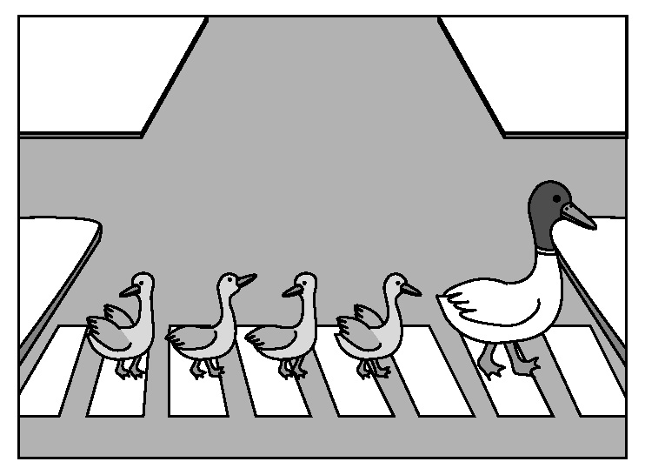
( ) 1. Look at the picture. The mother duck is ________ the baby
ducks across the street.
(A) carrying
(B) leading
(C) pushing
(D) watching
【答案】B
【出處】南一版第四冊第五課
【解析】由圖得知，母鴨正帶領著小鴨過馬路，故選(B)。
(A)正拿著 (C)正推著 (D)正看著。
( ) 2. Ms. Liu usually gives us a lot of homework, ________ she didn’t give us any today.
(A) but (B) if (C) or (D) so
【答案】A
【出處】南一版第一冊第四課
【解析】劉老師通常給我們很多作業，但是她今天沒有派任何的作業給我們。語氣轉折用but連接，故選(A)。(B)如果 (C)或者 (D)所以。
( ) 3. Playing games on the cellphone ________ popular with high school students.
(A) is
(B) are
(C) being
(D) to be
【答案】A
【出處】南一版第三冊第六課
【解析】在手機上玩遊戲很受中學生的歡迎。動名詞當主詞的句型，playing games on the cellphone是主詞，為一件事，故選(A)。
( ) 4. There ________ more than twenty clubs in our school. Which one would you like to join?
(A) has
(B) have
(C) is
(D) are
【答案】D
【出處】南一版第一冊第八課
【解析】在我們學校有超過20個社團。你要加入哪一個？此為There is/are的句型，故選(D)。
( ) 5. Diane had a bad cold last week. She is still too ________ to go mountain climbing with you.
(A) busy (B) short (C) weak (D) young
【答案】C
【出處】南一版第二冊第九課
【解析】Diane上週病得很重。她仍然太虛弱以致於無法跟妳去爬山。故選(C)。
(A)忙碌的 (B)矮的 (D)年輕的。
( ) 6. The book under Mary’s desk is ________, but I don’t know why it is there.
(A) us (B) me (C) my (D) mine
【答案】D
【出處】南一版第三冊第九課
【解析】在Mary書桌底下的書是我的，但是我不知道為什麼它會在那裡。本句使用所有格代名詞，故選(D)。
( ) 7. Last night a garbage truck hit a tree and turned over. Now the street is ________ with lots of garbage.
(A) dark (B) dirty (C) heavy (D) poor
【答案】B
【出處】南一版第二冊第九課
【解析】昨晚一臺垃圾車撞到一棵樹並且翻倒了。現在這條街有很多垃圾而很髒。故選(B)。(A)黑暗的 (C)重的 (D)可憐的。
( ) 8. It almost killed Kevin to take care of his baby sister for one afternoon. He wondered how his mom could do ________ every day.
(A) her (B) it (C) one (D) them
【答案】B
【出處】南一版第四冊第一課
【解析】照顧妹妹一下午幾乎要了Kevin的命。他很想知道他的媽媽每天是如何做這件事的。用代名詞it指照顧他的妹妹這件事，故選(B)。
( ) 9. Joyce tells her brother everything. She never ________ anything from him.
(A) covers (B) believes (C) hides (D) takes
【答案】C
【出處】南一版第一冊第七課
【解析】Joyce告訴她哥哥／弟弟每件事。她從不隱瞞他任何一件事情。故選(C)。
(A)覆蓋 (B)相信 (D)帶。
( )10. Ben always uses his birthday as a(n) ________ to ask Dad to buy him something expensive.
(A) action (B) excuse (C) prize (D) rule
【答案】B
【出處】南一版第四冊第五課
【解析】Ben總是以他的生日為藉口來要求他的爸爸買貴重的東西給他。故選(B)。
(A)行動 (C)獎品 (D)規則。
( )11. ________ that last piece of pie? If not, can I have it? I didn’t eat much this morning.
(A) Had you eaten (B) Were you eating
(C) Do you eat (D) Are you going to eat
【答案】D
【出處】南一版第三冊第七課
【解析】你要吃最後那一塊派嗎？如果沒有，我可以吃嗎？我今天早上沒有吃很多。此句為未來式句型「be going to＋原形V.」，故選(D)。
( )12. Everyone in the class enjoys playing chess ________ Bill; he thinks the game is boring.
(A) except (B) for (C) like (D) of
【答案】A
【出處】南一版第三冊第三課
【解析】在這班上的每個人都很喜歡下棋，除了Bill以外；他覺得這遊戲很無聊。故選(A)。(B)為了 (C)像 (D)…的。
( )13. In my school days, I ________ to English radio programs every day. That was how I learned English at that time.
(A) listen (B) have listened (C) used to listen (D) was listening
【答案】C
【出處】南一版第四冊第八課
【解析】在我念書時期，我習慣每天聽英語廣播節目。這就是我那時學英語的方法。此句用「used＋to＋原形V.」表達過去習慣，故選(C)。
( )14. Tom’s voice ________ when he talks about his neighbors. He speaks faster, his face becomes redder and you can almost see fire in his eyes.
(A) appears (B) drops (C) grows (D) rises
【答案】D
【出處】南一版第四冊第三課
【解析】當Tom談到他的鄰居時，他的聲音會提高。他講話愈快，他的臉愈紅，而且你幾乎可以在他的眼裡看到怒火，故選(D)。(A)出現 (B)掉落 (C)成長。
( )15. ________ other waiters in the restaurant have worked here longer than Clark; only Lois and Lana started working here before him.
(A) All (B) Most (C) Some (D) Few
【答案】D
【出處】南一版第四冊第二課
【解析】這家餐廳裡只有少數的服務生年資比Clark久，只有Lois和Lana在他之前就在這工作了，故選(D)。(A)所有的 (B)大部分 (C)一些。
第二部分：題組（第16-41題，共26題）
（16-17）
Making goulash
we don’t talk much,
Daddy and me.
 poem 詩
“The talking’s in the making, son,”
he smiles.
I see what he means.
It’s in the knife
meeting the beef,
in the dancing of potatoes
as they turn in the water,
in the singing
of boiling soup in the pot.
There are enough words
in the way
Daddy teaches me his famous dish
and the way he hugs me
when we finish.
Making goulash
we don’t talk much,
Daddy and me,
but everything is said.
(Ideas from Candace Pearson’s poem)

( )16. What are “Daddy and me” doing in the poem?
(A) Eating. (B) Singing. (C) Dancing. (D) Cooking.
【答案】D
【出處】南一版第六冊第四課
【解析】從詩中第三節提到刀子和牛肉、第四節提到馬鈴薯、水、和鍋子，且第五節第三行提到「爸爸教我他最著名的菜餚」，可推知他們在烹飪，故選(D)。
( )17. What can we most likely know about the speaker?
(A) He seldom understands his father.
(B) He enjoys his time with his father.
(C) He often makes goulash for his father.
(D) He wants to be as famous as his father.
likely 可能
【答案】B
【出處】南一版第六冊第四課
【解析】從詩中，作者表示他與父親在烹飪的過程中無太多交談，且在第五節中提到烹飪結束後他們擁抱，顯現出作者享受與父親一同做菜的時光，故選(B)。

（18-19）

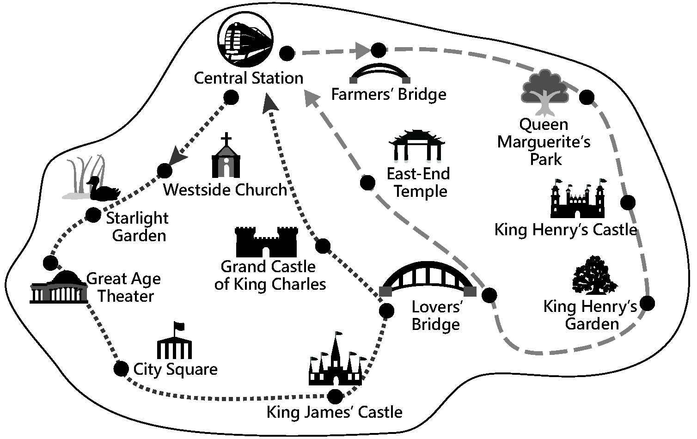
 OPENING HOURS
⬥ High Season (April to September): 9:00 – 18:00 every day
⬥ Low Season (October to March): 9:00 – 17:00 every day
 TICKET PRICES
⬥ Line A ( ): $20 each person
⬥ Line B ( ): $18 each person
 THINGS YOU SHOULD KNOW
⬥ Buses for both lines leave every hour from Central Station.
⬥ Line A takes one hour; Line B takes 50 minutes.
⬥ If you are taking your pet with you, please buy a seat for it at half price.
⬥ Save 10% if you buy tickets on the Internet.
⬥ Save 10% if you buy tickets for both lines.
⬥ Go to www.citysightbus.org for more information.

hostel （提供廉價食宿的）旅舍
( )18. Which is true about City Sight Bus tickets?
(A) It costs less to buy tickets on the Internet.
(B) People must pay the full ticket price for a pet.
(C) Tickets are more expensive in the high season.
(D) People save 10% if they buy two tickets for the same line.
【答案】A
【出處】南一版第四冊第四課、第五課
【解析】從文中倒數第三行得知，在網路上訂票可節省10%的票價，故選(A)。
( )19. Which is true about the bus lines?
(A) Line B takes more time. (B) Both lines cross Farmers’ Bridge.
(C) Both lines leave from Central Station. (D) There are more gardens to see on Line A.
【答案】C
【出處】南一版第四冊第四課、第五課
【解析】從圖中可看出Line A和Line B都是由Central Station出發，故選(C)。
（20-22）
Sarah: You’re VERY popular today. I’ve had seventeen calls asking for you.
Mike: Finally! After all these years of kicking and running, I’ve got my own fans! So what did they want? My photos? Do I need to sign my name? Are they starting a fan club for me?
Sarah: Well, let me ask you this: What day was yesterday?
Mike: Friday... Why?
Sarah: Did you forget something?
Mike: Did I forget... OH, NO! I didn’t pick up my soccer team’s sport shirts from the shop! And we’re having this big game tomorrow!
Sarah: Yeah. And from what I’ve heard, it’s your team’s most important game this season.
Mike: OK. I have to go fix this now.
Sarah: Too late. They’ve tried. It’s not open on the weekend. And if you want to know, they are Johnny, Ricky, Archie, Freddie...
Mike: I know, I know, everyone on my team. Oh, I’m a dead man now.
Sarah: Yeah, that was what they said on the phone, seventeen times.
( )20. Why were there seventeen calls asking for Mike?
(A) His team was angry at him.
(B) He is a popular soccer player.
(C) He did not show up for the game on Friday.
(D) His name did not appear on the list of players.
【答案】A
【出處】南一版第四冊第九課
【解析】從文中的第一行及第七行得知，Mike的隊友打了17通電話給他，因為他忘了去領取明天重要比賽要穿的運動衫，可推知大夥很生氣，故選(A)。
( )21. What does It mean in the dialogue?
(A) The shop. (B) The fan club. (C) The soccer game. (D) The soccer season.
【答案】A
【出處】南一版第四冊第九課
【解析】從文中的第七行得知Mike未去店裡取運動衫，而商店週末未營業，故選(A)。
( )22. What can we learn about Mike?
(A) He is nice to people from his fan club.
(B) He plays soccer with Johnny and Ricky.
(C) He found a way to fix the trouble he made.
(D) He decided not to go to the game on Sunday.
【答案】B
【出處】南一版第四冊第九課
【解析】從倒數第八行、第三～四行得知，Johnny和Ricky是Mike的足球隊隊友，故選(B)。
（23-25）
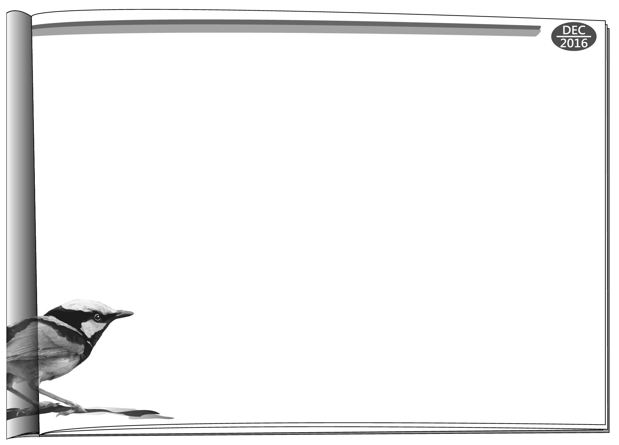
Animals have their special ways to deal with hard times in nature. The superb fairy-wren, one kind of bright-blue bird in Australia, is one example. This year, a ten-year study showed that this small bird has eggs of different sizes in different kinds of weather. When the weather is hot and dry, there is less food for young superb fairy-wrens, and they die easily. So the mother bird will make larger eggs to help her babies grow stronger inside before they break out of the eggs into the “hungry” world.
However, not all mother birds are able to do this trick. Only those with at least one male child can. When the weather is “good,” the mother will make smaller eggs, and her sons will bring food back for their baby brothers and sisters from the eggs.
With her sons’ help, the mother can save more energy to make larger
eggs when the weather is bad. Isn’t this amazing?
male 雄性 energy 能量

( )23. Which is the best title for this reading?
(A) Australia: The Best Place for Birds.
(B) Mother Bird Fights Weather Changes.
(C) Larger Mother Birds Have Larger Eggs.
(D) Family Love: Brothers & Sisters Work Together.
title 標題
【答案】B
【出處】南一版第一冊第八課、第四冊第四課
【解析】由第二～三行得知，這種鳥類為了適應不同的氣候，牠們所產下的蛋大小也不一樣，故選(B)。
( )24. What does this trick mean in the reading?
(A) Having eggs of different sizes.
(B) Growing stronger inside the egg.
(C) Saving food for weaker baby birds.
(D) Helping baby birds break out of the eggs.
【答案】A
【出處】南一版第一冊第八課、第四冊第四課
【解析】由第一段得知，鳥媽媽為了要使牠的小孩在孵化前更強壯，以適應炎熱乾燥的氣候和食物較少的環境，因此牠必須產出大一點的蛋，故選(A)。
( )25. What can we learn about superb fairy-wrens from the reading?
(A) Male birds can usually live for ten years.
(B) Baby birds grow well in hot, dry weather.
(C) Young male birds share the job of feeding the baby birds.
(D) Mother birds make smaller eggs when there is less food outside.
【答案】C
【出處】南一版第一冊第八課、第四冊第四課
【解析】由第二段第一～三行得知，至少一隻的公幼鳥會出去覓食來幫助鳥媽媽餵食更小的幼鳥，故選(C)。
（26-28）
Here are two pieces of news that Annie collected for her report.
work 作品
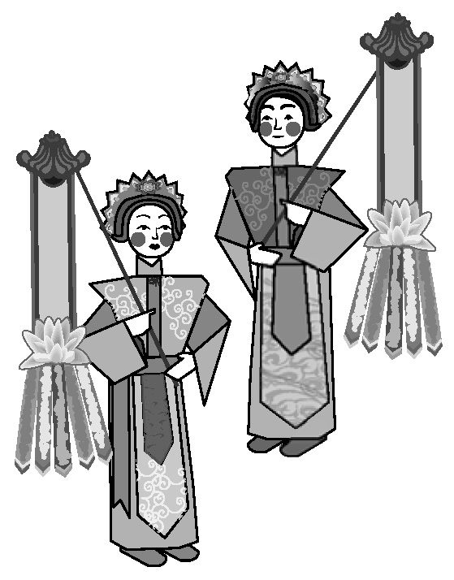
Papier-mâché is works of art that are made of paper. In Taiwan, it is known as zhizha and is usually burned as a gift for dead people. Taiwan’s papier-mâché is dying because it is not much needed now. However, this dying art won a Frenchman’s heart when he visited the island. He then invited one of the papier-mâché shops, Hsin Hsin Paper Offering Store, to show their beautiful works in France. The shop owner’s son also used papier-mâché in a way that no one ever thought of—making a movie with it.

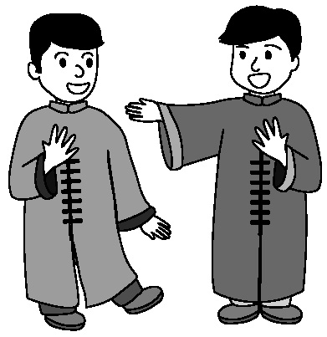
Stan Lai is very important in Taiwan’s theater. He brought changes to Chinese theater art of the old days to make it closer to our life experiences and easier to understand. One of his most famous works is That Evening, We Performed Crosstalk (1985). It was such a smash hit that people became interested again in xiangsheng, a show of funny talk between two actors. This art used to be a hobby that only a few people shared, but Lai has opened a bigger market for it. Now it has fans across all ages.

( )26. What idea is talked about in both pieces of news?
(A) More young people need to join in making art.
(B) People’s ways of enjoying art change with time.
(C) Bringing important art works to Taiwan from abroad.
(D) Giving new life to old arts that were almost forgotten.
【答案】D
【出處】南一版第五冊第一課
【解析】由第一則新聞的第三行得知臺灣的papier-mâché（紙紮文化）即將消失，但一位法國人因喜愛此文化而賦予它新生；第二則新聞的第一～二行提到，Stan Lai（賴聲川）改變相聲文化，使其更貼近現代人的生活，故選(D)。
( )27. What does it mean when something is a smash hit?
(A) It is old.
(B) It is successful.
(C) It is foreign.
(D) It is useful.
【答案】B
【出處】南一版第五冊第一課
【解析】由前一句提及Stan Lai最著名的作品，並在後面提到人們進而更對相聲感興趣，顯示出了它的成功，故選(B)。
( )28. What do we know from the news?
(A) Lai has taught xiangsheng in many schools.
(B) Lai often puts his own life stories into his art works.
(C) The owner of Hsin Hsin Paper Offering Store is a Frenchman.
(D) People do not burn papier-mâché for dead people as often as before.
【答案】D
【出處】南一版第五冊第一課
【解析】第一則新聞的第一～三行提及papier-mâché是燒給往生者的一份禮物，但此文化現在已經不再被大眾所需要，故選(D)。
（29-32）
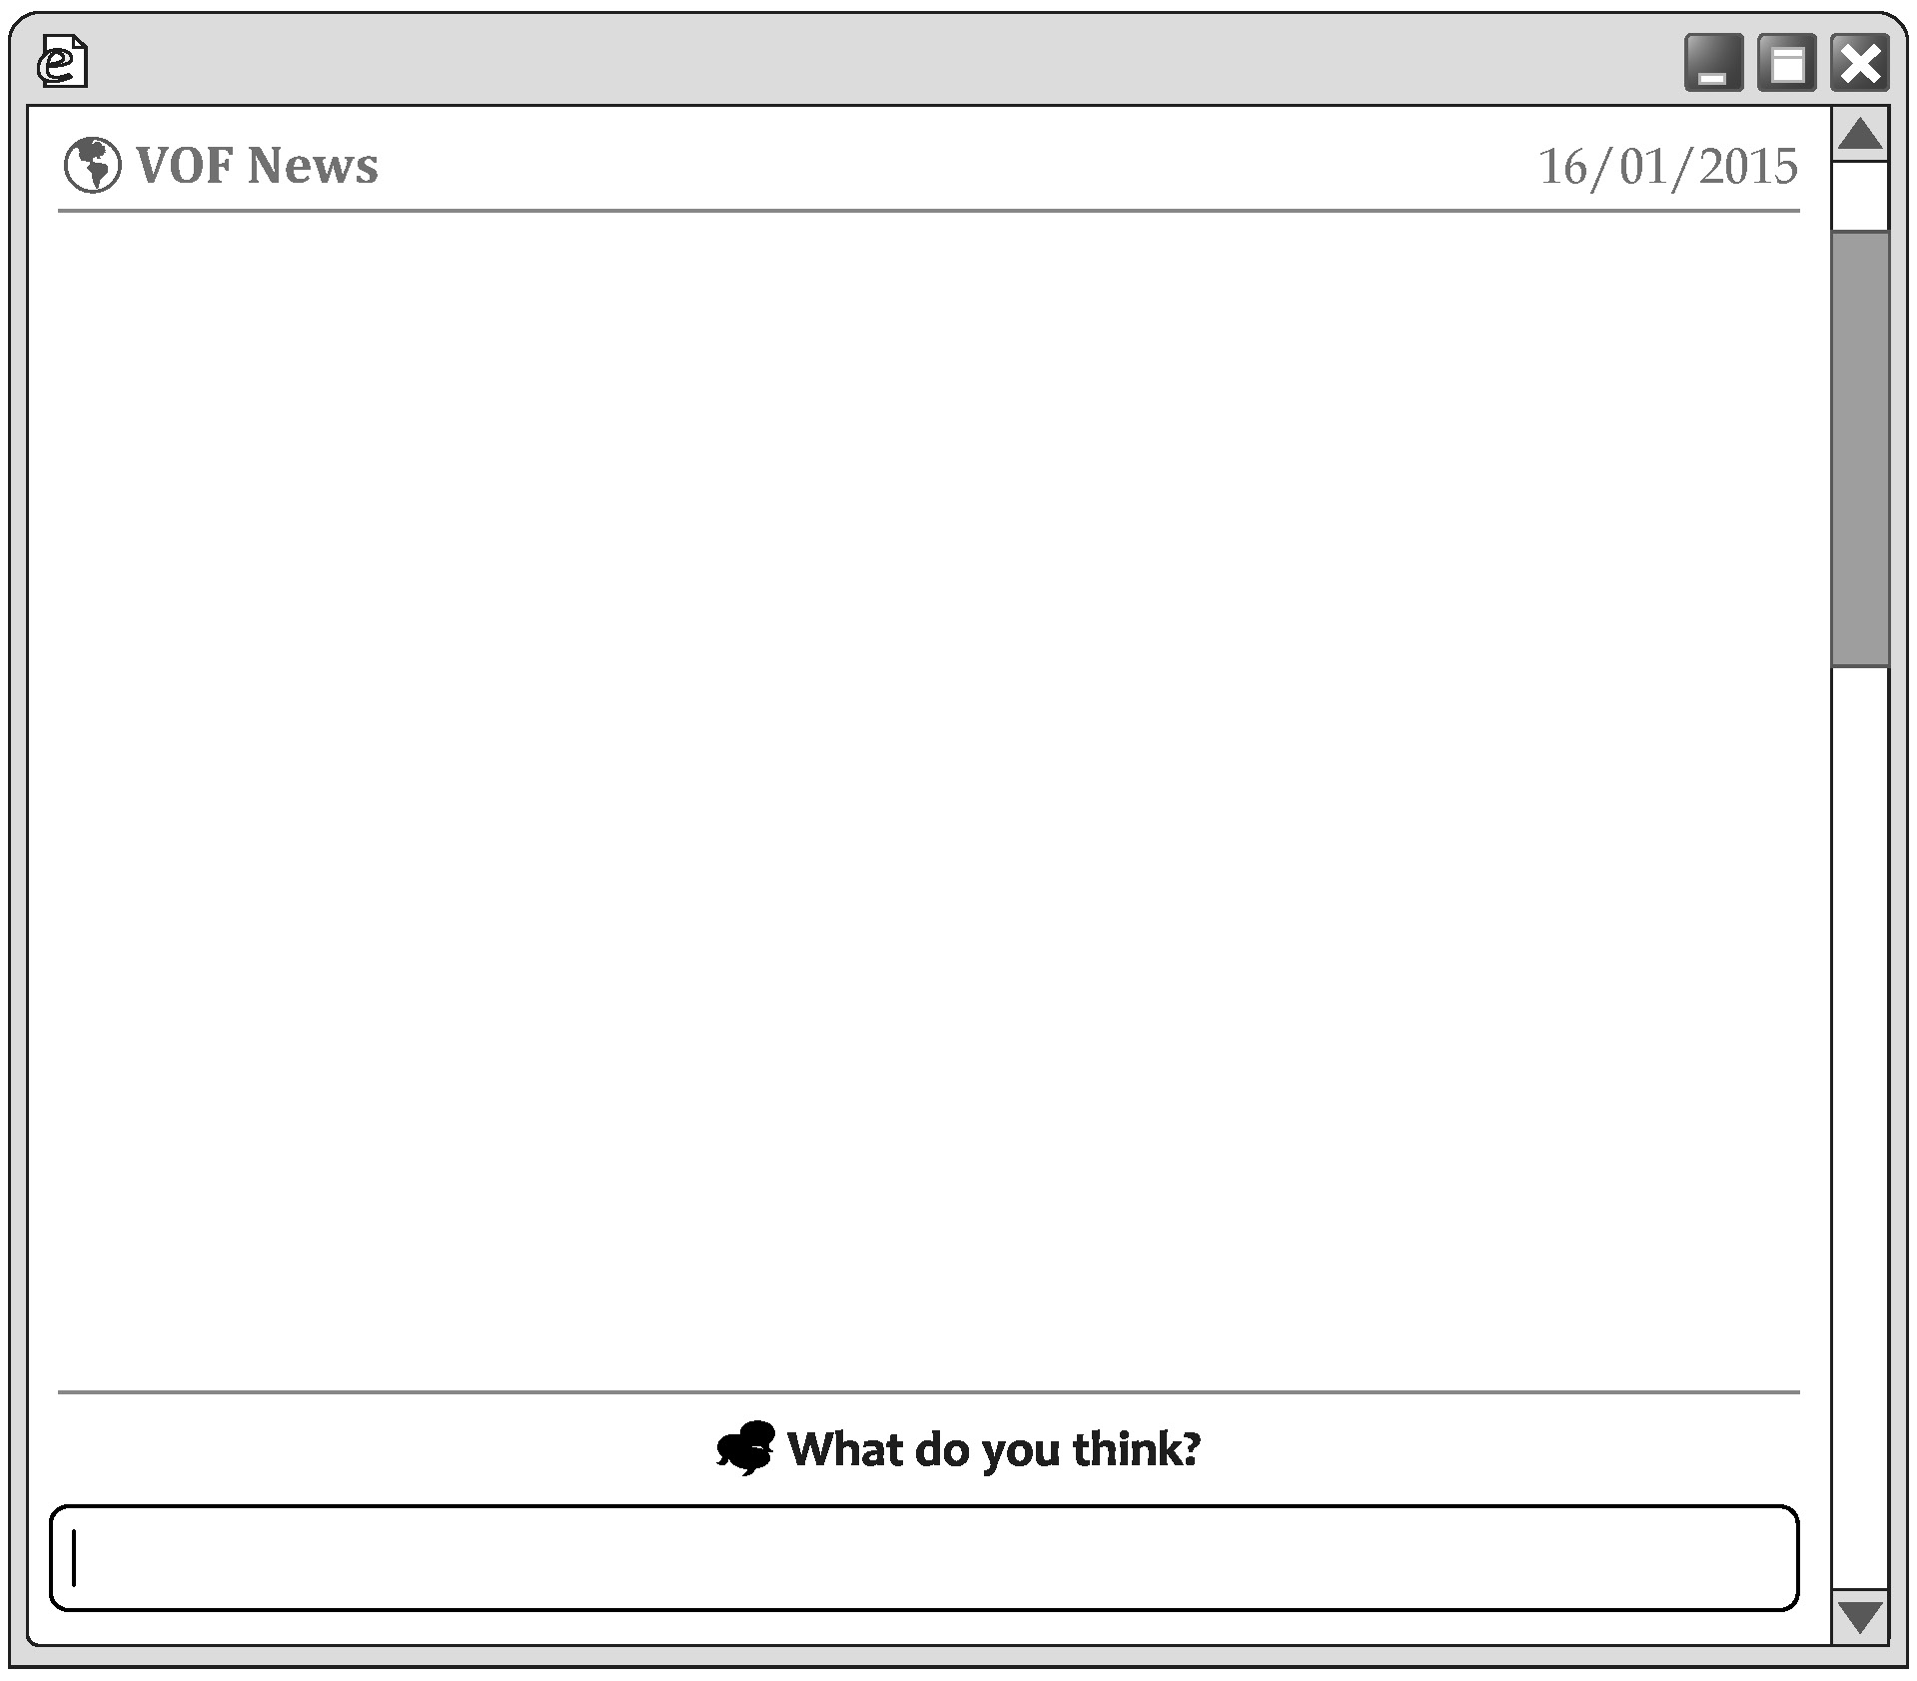

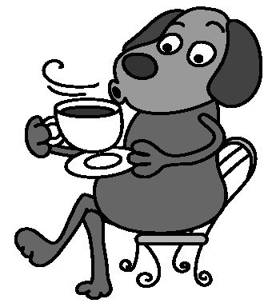
For many people, having a cup of coffee right out of bed is the best way to start a day. But a report from Asap Science says otherwise. It says the worst time for coffee is soon after we get up. When we wake up, our bodies start to make cortisol. Cortisol helps us to think clearly and be quick to understand and act. The cortisol levels rise after we wake up and climb to the highest in about an hour. So there are two problems when we drink coffee during this time: (1) our bodies will make less cortisol,
and (2) the cortisol will make coffee less useful. And that’s why some of us drink more and more coffee.
Then, when’s the best time to have coffee? When the cortisol levels are going down, the report says. Cortisol levels are usually highest between 8 a.m. and 9 a.m., between noon and 1 p.m., and between 5:30 p.m. and 6:30 p.m. So if you want to have coffee, enjoy it after these times, and this popular drink will help you the most.

cortisol 皮質醇 level 數值；濃度

( )29. Which idea is talked about in the news?
(A) How often we should drink coffee.
(B) What happens when we have too much coffee.
(C) How to help the body make the cortisol we need.
(D) What happens when we have coffee at the wrong time.
【答案】D
【出處】南一版第三冊第九課、第六冊Reading CAP II
【解析】從文中第一段倒數第四行起得知，在錯誤的時間飲用咖啡會產生兩種問題，故選(D)。
( )30. What does it mean when someone thinks otherwise about something?
(A) They are serious about it. (B) They have no idea about it.
(C) They think differently about it. (D) They do not think it is a problem.
【答案】C
【出處】南一版第三冊第九課、第六冊Reading CAP II
【解析】從文中第一～二行得知，大多數人認為喝咖啡的最佳時機是在早上起床後，然而Asap Science提出不同的看法，故選(C)。
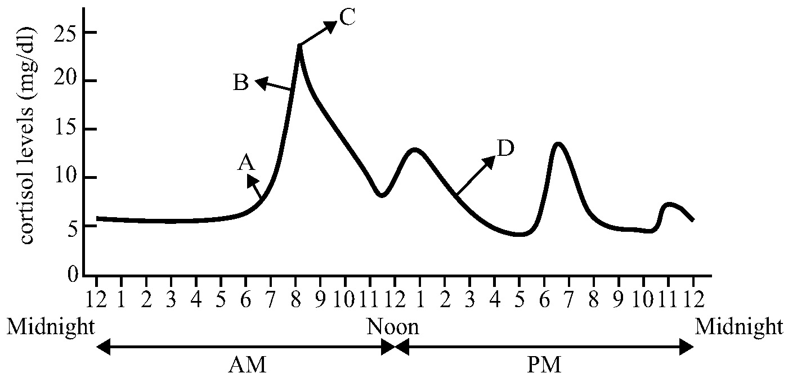
( )31. The picture below shows how the cortisol levels rise and fall during the day. From the news, which is a good time for coffee?
(A) A.
(B) B.
(C) C.
(D) D.
【答案】D
【出處】南一版第三冊第九課、
第六冊Reading CAP II
【解析】由文中第二段第二句得知，喝咖啡的最佳時間是在cortisol的體內濃度降低之後，故選(D)。
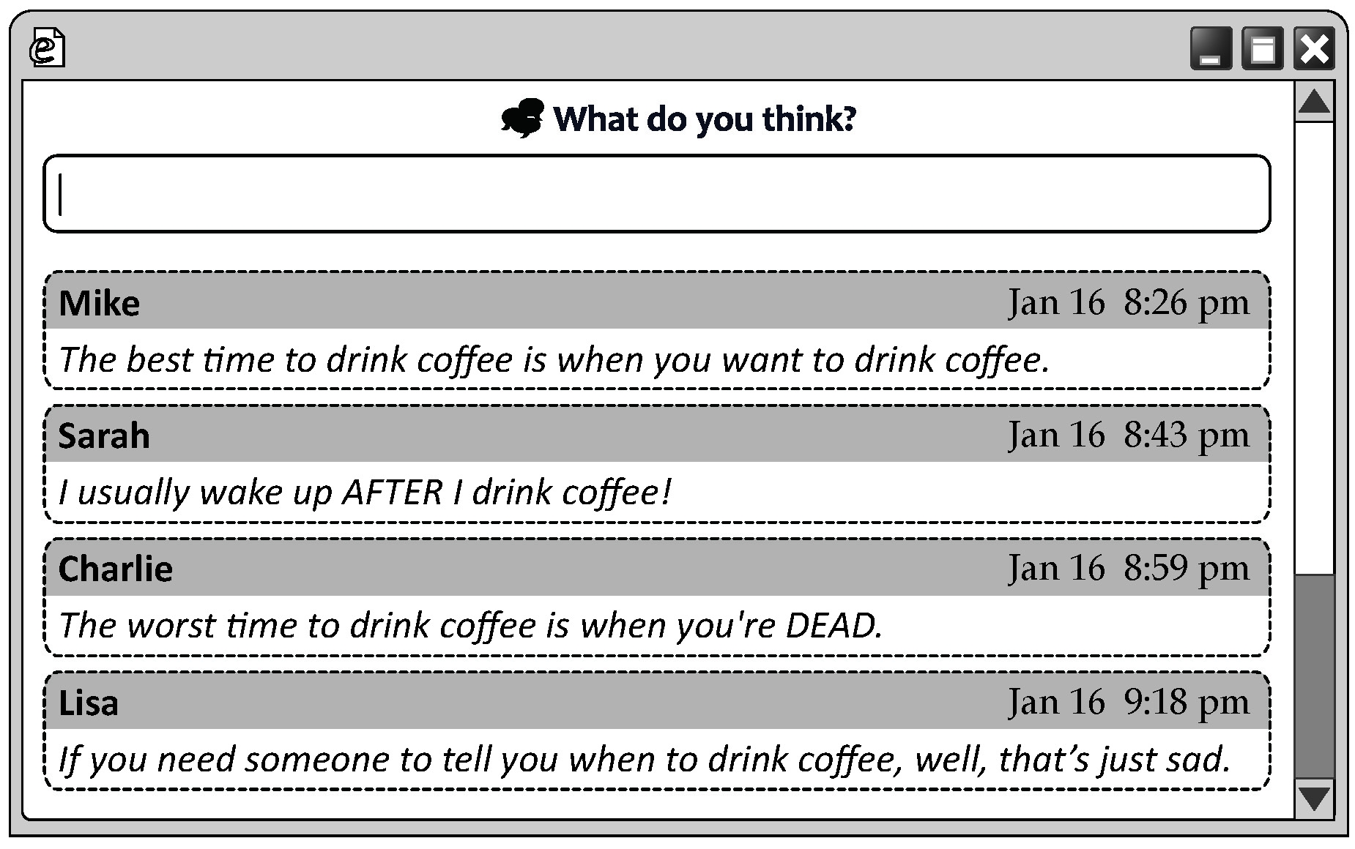
( )32. Four people read the news and wrote what they thought about it.
What did they think about the news?
(A) They wanted to try what it said. (B) They were sad about what it said.
(C) They did not agree with what it said. (D) They were not surprised at what it said.
【答案】C
【出處】南一版第三冊第九課、第六冊Reading CAP II
【解析】Mike覺得當你想喝咖啡時就是最好的時機；Sarah表示她喝完咖啡後才會清醒；Charlie認為當你死亡時才是喝咖啡最糟的時機；Lisa表示你需要別人告知何時才能喝咖啡，那是件憂傷的事，故選(C)。
（33-35）
Below is part of a new shopping center’s market report.
Our busiest time is weekend afternoons, between 1:30 p.m. and 3:30 p.m. About half the business of the week is done then. So it would be better if we move Weekend’s Best Buy from Saturday evening to Saturday afternoon when there may be more shoppers during the sale. We should also think about having more free buses during the weekend, as 75% of the shoppers who were interviewed said two buses an hour are just not enough.
Weekend evenings are second busiest, though it is not as good as last season. An interesting fact is that business is better on weekday evenings, usually one hour before closing, than on weekend mornings. Most of the shoppers then are people who live near or working parents who do their last-minute shopping. They together make up almost 60% of the business on weekday evenings. It might bring in more business if we open half an hour longer during weekdays, until 10:30 p.m.

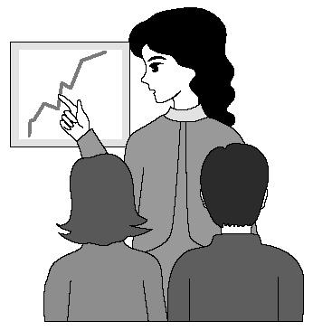
as 由於 make up 構成；組成
( )33. What does the report NOT suggest?
(A) Having more free buses for shoppers.
(B) Changing the opening hours on weekdays.
(C) Making plans to help weekday morning business.
(D) Changing the time of the special sale on weekends.
suggest 建議
【答案】C
【出處】南一版第三冊第九課
【解析】由報告的第二段第一～三行得知，購物中心的繁忙高峰期在平日傍晚，通常在打烊前一小時，此時段更勝於週末早上，故選(C)。
( )34. What does the report say about the shopping center?
(A) Its business on weekdays is not as good as last season.
(B) It has a special sale one hour before closing every day.
(C) Most of the shoppers take the free buses to the shopping center.
(D) A large part of its shoppers on weekday evenings are working parents.
【答案】D
【出處】南一版第三冊第九課
【解析】由報告的第二段第三～五行得知，大多數平日傍晚的購物者為住在附近的人，或是總在最後一秒才購物的上班族，這些人的消費將近占了平日傍晚的60%，故選(D)。
( )35. Which picture is most likely used in the report?
(A)
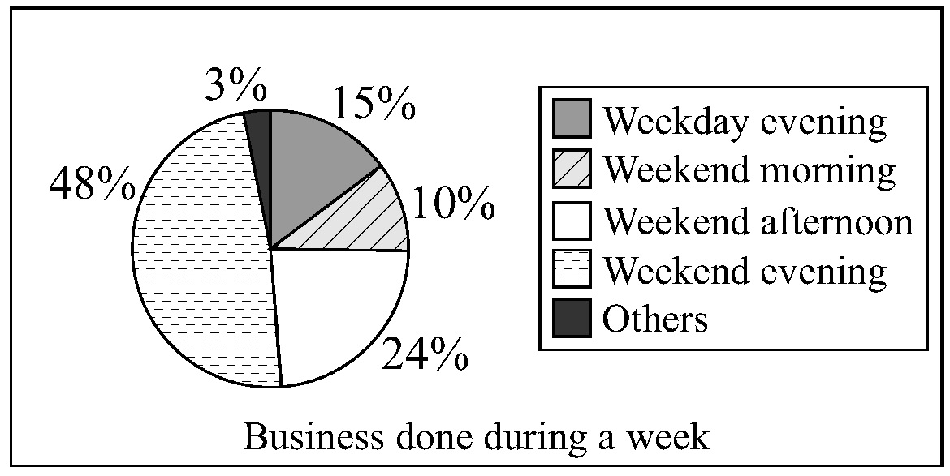
(B)
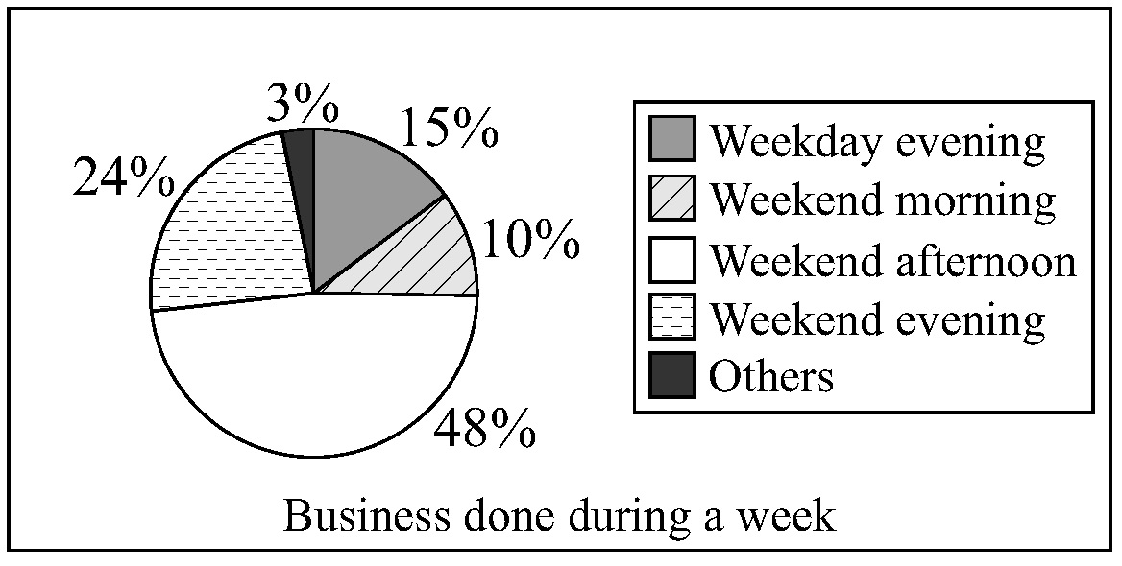
(C)
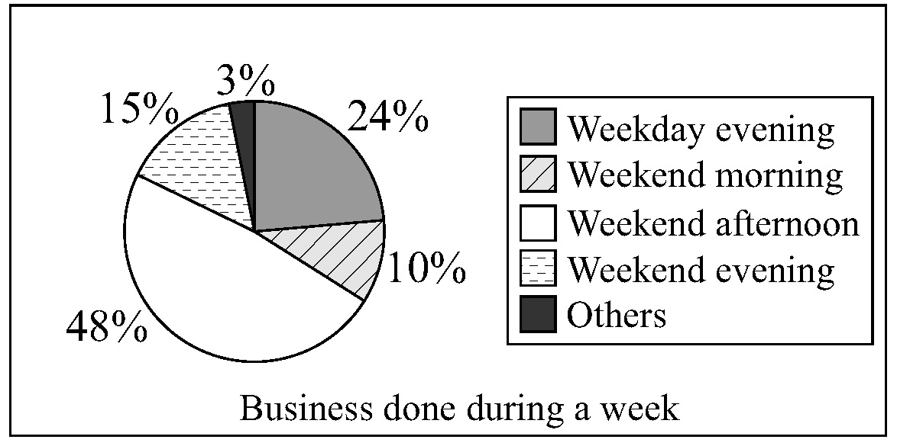
(D)
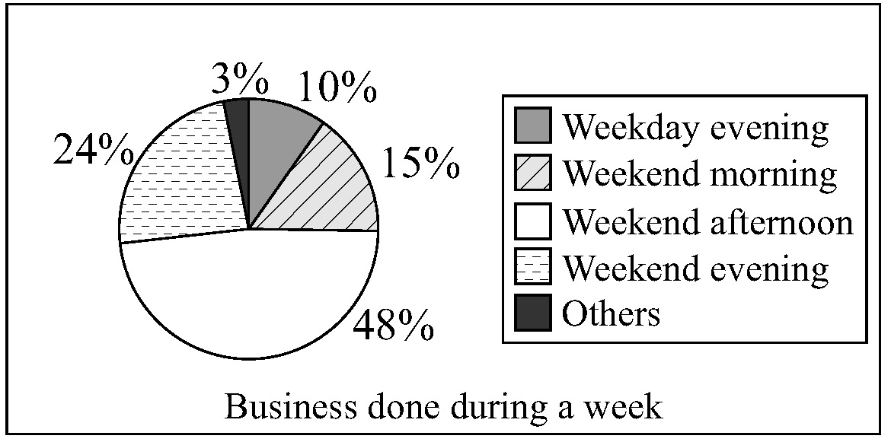
【答案】B
likely 可能
【出處】南一版第三冊第九課
【解析】由文中得知最繁忙的時段為週末下午，第二繁忙的時段為週末傍晚，而平日傍晚更勝於週末早上，故選(B)。
（36-37）


Dear Maggie,
I know you won’t be happy but I still have to say this again. It hurts me to think that you’re going to . I know you’ve always wanted to be like those actresses with big eyes and slim legs, but in fact you are already beautiful. What you are born with makes you special because nobody looks the same as you.
It worries me more that . But sadly, there’s no quick fix to this, not even with the doctor’s help. If you don’t try to like yourself first, no one else will. People like you not because of your face, but because of your heart. You need to understand this first. Until you understand this, nothing is going to be different even if you have this change.
I truly hope you think this through again.
Love,
Linda

( )36. (A) change the way you are
(B) give up being an actress
(C) travel with a theater group
(D) run away from your friends
【答案】A
【出處】南一版第五冊第七課Language In Use
【解析】由下一句得知，Linda對Maggie提到「我知道妳一直想像那些女演員一樣，有著大眼睛及細長的腿，但是你已經很美了」，所以可得知前一句Linda對Maggie說「你要改變你的樣子對我而言很受傷」，故選(A)。
( )37. (A) you’re too shy to talk with people
(B) you just don’t want to be like others
(C) you don’t think you’re good enough
(D) you don’t know what you’ve missed
【答案】C
【出處】南一版第五冊第七課Language In Use
【解析】由前一段得知Maggie想要改變容貌，可推知Linda擔心Maggie認為她不夠美，得知「你認為你不夠好，這件事使我更擔憂」，故選(C)。

（38-41）

throne 王位
Elizabeth Alexandra Mary Windsor was born in London on April 21, 1926. No one thought one day she the queen of the UK. After her grandfather, King George V, died in 1936, Elizabeth’s uncle, Prince Edward, became King Edward VIII. Edward in love with a married American woman long before, and he decided to marry her after he became the king. However, Edward was asked to choose between the throne and his love. Finally, he decided to give up the throne.
. After Edward VIII gave up the throne, Elizabeth’s father became King George VI. As the oldest child without any brothers, Elizabeth became next in line to the throne. She needed to say goodbye to her good old life and prepare to be a queen. After her father died in 1952, she became Queen Elizabeth II.
Ever since she became head of her country, Queen Elizabeth II : She has held meetings with important people in the UK, and has visited many foreign countries. In the few hours she keeps to herself, however, she reads and enjoys horseback riding.

( )38. (A) has become (B) became
(C) had become (D) would become
【答案】D
【出處】南一版第三冊第二課
【解析】「沒有人認為她有一天將會成為英國的女王。」由thought得知此為過去式句型，故選(D)。
( )39. (A) has fallen (B) is falling
(C) had fallen (D) would fall
【答案】C
【出處】南一版第三冊第二課
【解析】「Edward在很久以前就已經與一位美國女人墜入愛河，他決定在他成為國王之後娶她為妻。」比過去式更早發生的事須使用過去完成式，故選(C)。
( )40. (A) This changed Elizabeth’s life
(B) It was not easy to give up the throne
(C) It was good news to Elizabeth and her family
(D) This part of history made the UK a strong country
【答案】A
【出處】南一版第三冊第二課
【解析】由第二段倒數第二～三行得知，「她必須跟她以前的美好生活說再見，並學著當一位女王」，可得知這件事改變了Elizabeth的生活，故選(A)。
( )41. (A) has worked hard for the UK
(B) has been popular with the people of the UK
(C) has been the queen of the UK for a long time
(D) has brought the people of the UK much closer
【答案】A
【出處】南一版第三冊第二課
【解析】由後面提到「她跟英國的重要人士開會，並拜訪了許多國家」可得知，她非常努力地帶領英國，故選(A)。
108年國中教育會考 南一書局 敬贈
會考解析
免費下載
英語
英 語 科 聽力題本
第一部分：辨識句意（第1-3題）
作答說明：每題均有三張圖片，請依據所聽到的句子，選出符合描述的圖片，每題播放兩次。
示例題：你會看到
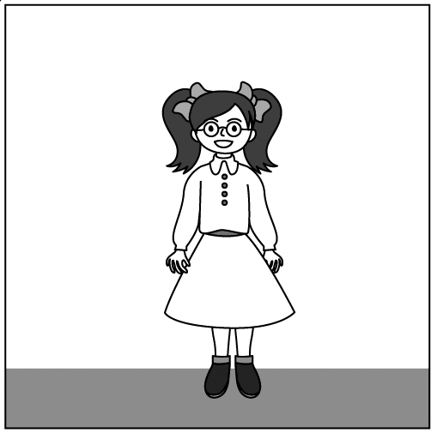  (A) | 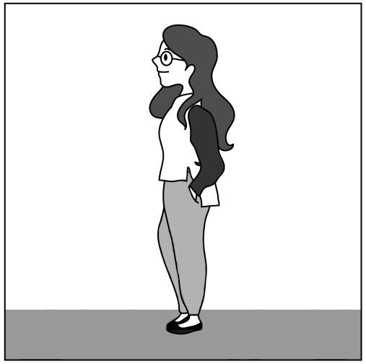  (B) | 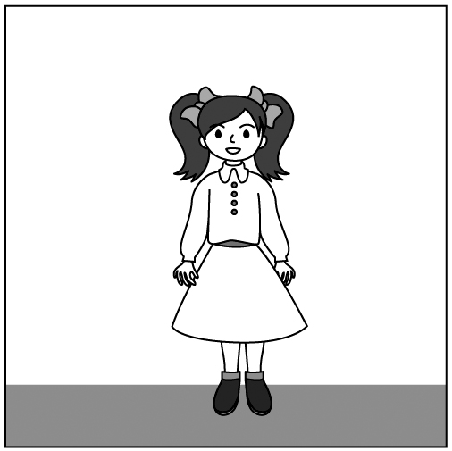  (C)
然後你會聽到……(播音)。依據所播放的內容，正確答案應該選A，請將答案卡該題「」的地方塗黑、塗滿，即：
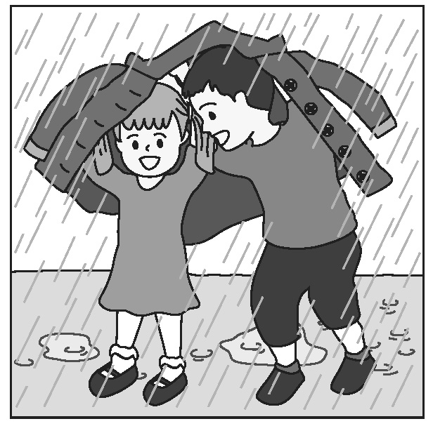
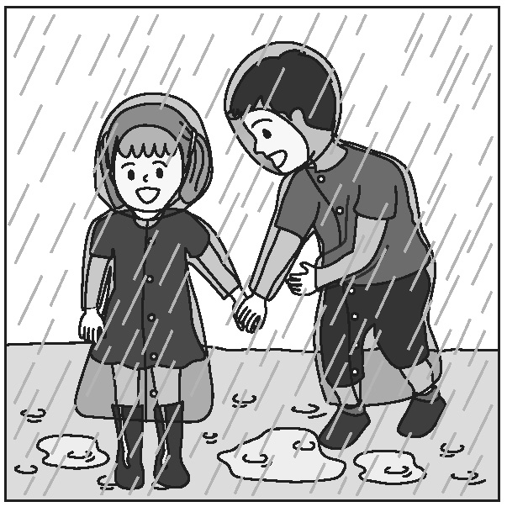
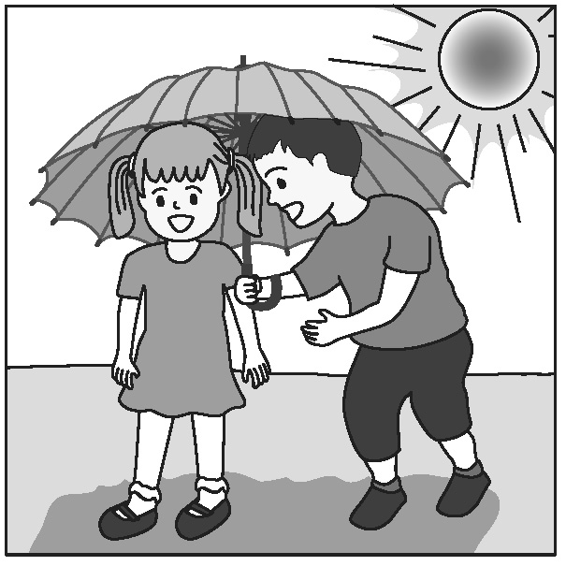
( ) 1. (A) (B) (C)
【答案】A
【出處】南一版第四冊第八課
【解析】The boy and the girl are hiding from the rain under a coat.
（男孩跟女孩在大衣下躲雨。）
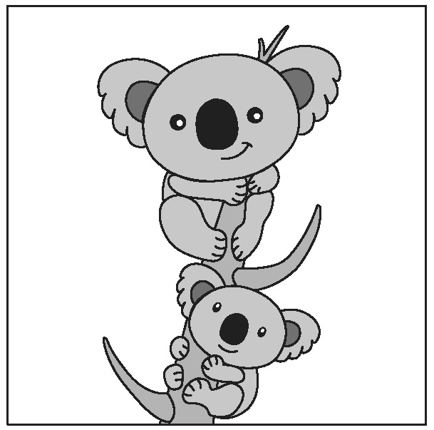
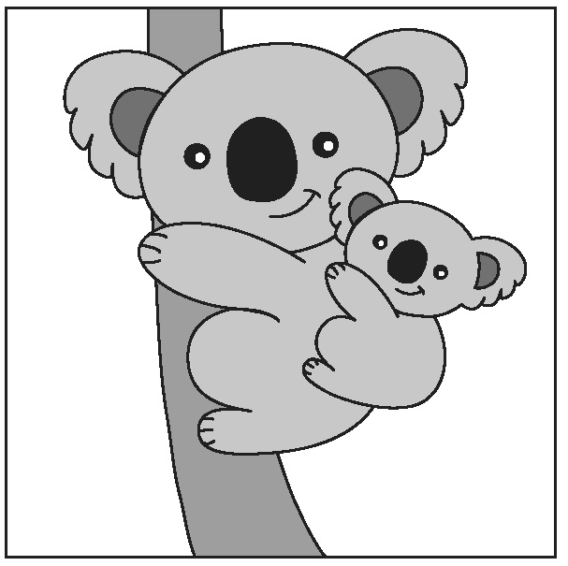
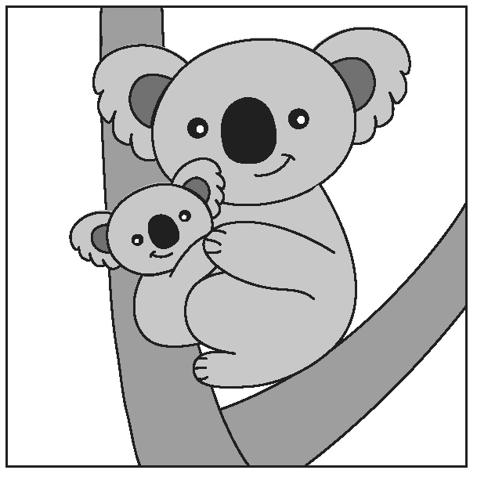
( ) 2. (A) (B) (C)
【答案】B
【出處】南一版第三冊第三課
【解析】A baby koala is riding on its mother’s back.
（一隻小無尾熊騎在媽媽的背上。）
( ) 3. (A) (B) (C)
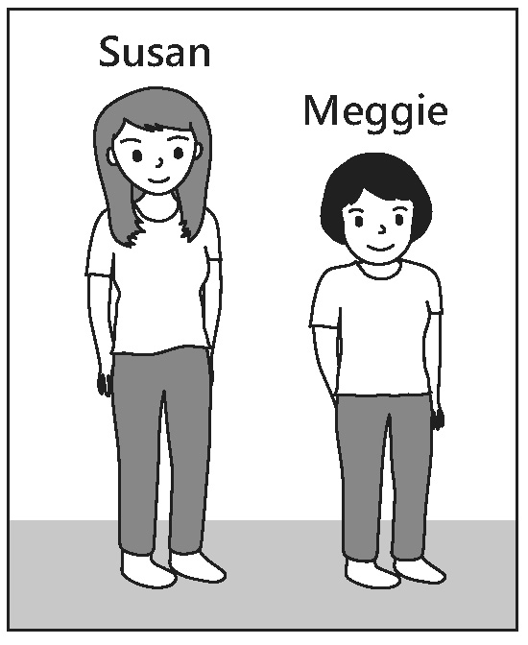
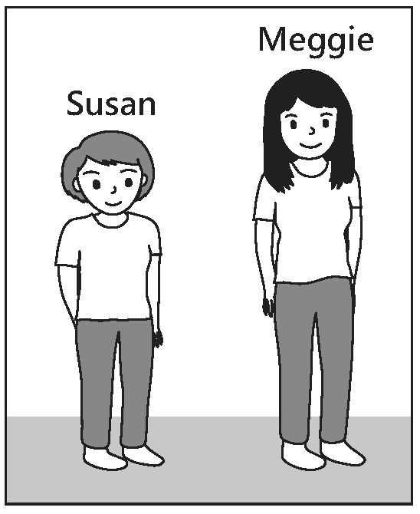
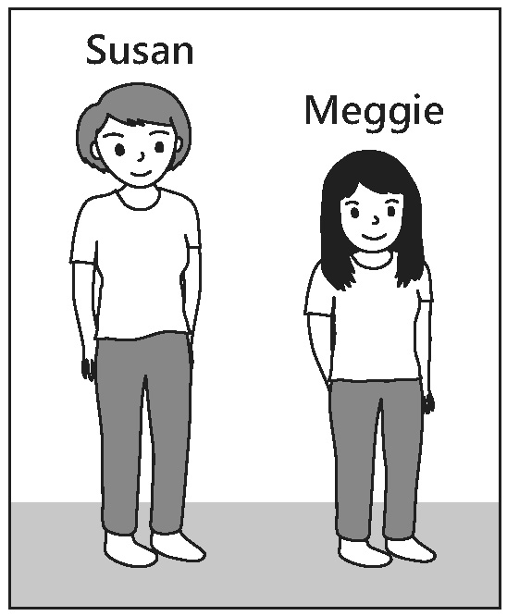
【答案】A
【出處】南一版第五冊第七課
【解析】The Smith girls are both cute. The taller one with short hair is Susan, and the other one is Meggie.（Smith家的女孩們都很可愛。比較高且短頭髮的是Susan，另一個則是Meggie。）

第二部分：基本問答（第4-10題）
作答說明：每題均有三個選項，請依據所聽到的內容，選出一個最適合的回應，每題播放兩次。
示例題：你會看到
(A) She is talking to the teacher.
(B) She is a student in my class.
(C) She is wearing a beautiful dress.
然後你會聽到……(播音)。依據所播放的內容，正確回應應該選B，請將答案卡該題「」的地方塗黑、塗滿，即：
( ) 4. (A) You can try it on.
(B) I went to the store on foot.
(C) It’s a present from my aunt.
【答案】C
【出處】南一版第一冊第三課
【解析】Your sweater looks beautiful. Where did you get it?
（妳的毛衣看起來很漂亮。在哪裡買的？）

( ) 5. (A) I like guavas the best.
(B) I hate bananas and peaches.
(C) I eat French fries all the time.
【答案】A
【出處】南一版第四冊第一課
【解析】What’s your favorite food?（你最喜歡什麼水果？）
( ) 6. (A) I don’t have a car, either.
(B) Don’t worry; I’ll be careful.
(C) I know, but I hate to go alone.
【答案】B
【出處】南一版第二冊第八課
【解析】Are you sure about going home alone? It’s quite late now. I can drive you, you know.
（妳確定妳要自己回家？現在很晚了，你知道我可以載妳回家的。）

( ) 7. (A) I’m serious.
(B) I hope it’s good.
(C) I’ll have the same.
【答案】C
【出處】南一版第三冊第八課
【解析】I think I’ll just have some soup. Maybe a salad, too. How about you?
（我想我只要喝點湯。或許再加個沙拉。你呢？）

( ) 8. (A) Thanks. You are very kind.
(B) Really? I bought it yesterday.
(C) Good idea. Just leave the bag there.
【答案】A
【出處】南一版第一冊第五課
【解析】Let me help you with the bag.（我來幫你提這個袋子吧。）

( ) 9. (A) I think it is quite convenient.
(B) It’s just right across the park there.
(C) It might take ten to fifteen minutes.
【答案】B
【出處】南一版第四冊第五課
【解析】Excuse me. How do I get to Saint Paul’s Church?
（請問一下，我要怎麼到聖保羅教堂？）

( )10. (A) He is afraid to fly.
(B) He has business there.
(C) It takes sixteen hours to fly to the US.
【答案】B
【出處】南一版第五冊第五課
【解析】Do you know why John has flown to the US again?
（你知道為何John又飛往美國了嗎？）
第三部分：言談理解（第11-21題）
作答說明：每題均有三個選項，請依據所聽到的對話或短文內容，選出一個最適合的答案，每題播放兩次。
示例題：你會看到
(A) 9:50. | (B) 10:00. | (C) 10:10.
然後你會聽到……(播音)。依據所播放的內容，正確答案應該選B，請將答案卡該題「」的地方塗黑、塗滿，即：
( )11. (A) PE.
(B) Math.
(C) Music.
【答案】C
【出處】南一版第二冊第五課
【解析】(Clapping hands)（拍手聲）
W: That’s wonderful, students! All of you have beautiful voices. But please sing louder. You can stand up or drink some water if you think it helps. Let’s try it again. Three, two, one, go.
（學生們，太棒了！你們的聲音真是太美妙了，不過請唱大聲點。如果覺得有幫助的話，你們可以站著或者喝點水。讓我們再試一次吧！1，2，3，唱。）
Q: Which class are the students in?
（學生們在上什麼課？）

( )12. (A) February 13.
(B) February 14.
(C) February 15.
【答案】C
【出處】南一版第二冊第五課、南一版第三冊第四課
【解析】 W: When will we hold the party next week?
（下星期何時舉辦派對？）
M: Lucy wanted it to be on February 13 or 14.
（Lucy想要在2月13日或14日舉辦。）
W: But don’t you think it’s easier for everyone to come on Saturday?
（不過你不認為星期六對每個人來說，都比較容易出席嗎？）
M: Then the party should be on February 15?
（所以派對在2月15日舉辦的意思嗎？）
W: I think so. I’ll ask Lucy first if the date is OK.
（我是這麼認為。我會先問Lucy這日期有沒有問題。）
Q: When does the woman want to have the party?
（對話中的女人想要何時舉辦派對？）
( )13. (A) A cook.
(B) A salesman.
(C) A waiter.
【答案】C
【出處】南一版第五冊第七課
【解析】 M: Is everything all right?
（餐點都還好嗎？）
W: Yeah, the food was very good.
（是呀，食物都非常棒。）
M: Would you like some dessert?
（想來點甜點嗎？）
W: Yes. Can I see the menu?
（好，可以給我菜單嗎？）
M: Sure. Let me clean the table for you and then I’ll bring you the menu.
（當然。讓我先為您清理桌子，稍後再拿菜單給您。）
W: Thanks. And, hmm, could you also bring me some water?
（謝謝。嗯，可以也給我水嗎？）
M: Of course. I’ll be back in a second.
（當然。等會就來。）
Q: Who is the man?
（這個男人是誰？）

( )14. (A) Visiting a new neighbor.
(B) Moving into a new apartment.
(C) Shopping for a table and a refrigerator.
【答案】B
【出處】南一版第一冊第七課
【解析】 M: You have a lovely apartment, Jane.
（Jane，妳的公寓很漂亮。）
W: Thanks. I like it very much. It’s bigger than my old one.
（謝謝，我很喜歡這個公寓。它比我原先的公寓來得大。）
M: Umm..., so, where should we put the table?
（嗯，這個桌子要放哪裡？）
W: Let’s put it in the dining room.（放在餐廳好了。）
M: OK.（好。）
(Bang)（砰）
W: Whew! That was heavy. Umm, the table looks nice here. Now, we need to carry the refrigerator into the kitchen.
（呼！這真是重呀。嗯，桌子放在這裡真不錯。現在，我們需要把冰箱放進廚房裡。）
Q: What is the woman doing?（這個女人在做什麼？）
( )15. (A) He has seen it already.
(B) He will see it next week.
(C) He thinks it is a bad movie.
【答案】A
【出處】南一版第五冊第八課
【解析】 W: I’ve got two tickets for Spiderman. Do you want to see it together?
（我有兩張蜘蛛人的票。你要跟我一起去看嗎？）
M: Too bad. I saw it with my sister last week.
（真是太不湊巧了。我上個星期才跟我妹妹去看過。）
W: Did you enjoy it?
（你喜歡嗎？）
M: It’s one of the best movies I’ve seen. Let’s talk more about it after you see it.
（這真是我看過最棒的電影之一。等妳看過之後，我們再多討論些。）
Q: Why doesn’t the man go see the movie with the woman?
（為何男人不跟女人一起去看這部電影？）

( )16. (A) Invite Aunt Sue to tea.
(B) Visit Aunt Sue on another day.
(C) Go to the theater on another day.
【答案】B
【出處】南一版第四冊第八課
【解析】 W: Do you think we have time to stop by Aunt Sue’s place before we go to the theater?
（你覺得在我們去戲院之前，有時間去Sue嬸嬸家短暫停留一下嗎？）
M: Why?
（要做什麼呢？）
W: I’ve got this handbag for her. I bought it when I was in Japan.
（我要拿這個手提包給她。這是我在日本時買的。）
M: Well, you know Aunt Sue. She never lets you leave her house before at least three pots of tea.
（嗯，妳知道Sue嬸嬸的。在她家至少得停留三壺茶的時間，她才會讓妳離開。）
W: Umm, yeah, you’re right. Next time then.
（你說得沒錯。那麼，下次吧。）
Q: What did the woman decide to do?
（這個女人決定怎麼做？）

( )17. (A) She thinks he is a serious person.
(B) She thinks he should bake more cakes.
(C) She thinks he wants something from her.
【答案】C
【出處】南一版第四冊第四課
【解析】 M: I’ve made a cake for you.
（我做了一個蛋糕給妳。）
W: Oh, thanks. Wait a minute. There’s something you want, isn’t there?
（喔，謝謝。等等，你有什麼目的，對吧？）
M: Can’t I just be nice?
（我不能只是單純想要對妳好嗎？）
W: I’ve known you for years.
（我認識你很久了。）
M: Do you really see me that way?（妳真的這樣看我？）
W: Seriously, just say it.（認真點，說吧。）
M: Well, if you must ask. I was wondering....
（好吧，如果妳堅持這樣問，我在想…）
Q: What does the woman think when the man gives her the cake?
（當男人給女人蛋糕時，女人在想什麼？）

( )18. (A) She failed her tests this week.
(B) She was too late to catch a boat.
(C) She lost the chance to get a ticket.
【答案】C
【出處】南一版第三冊第二課
【解析】 M: Hey, have you bought a ticket to AJ’s music show?
（嘿，妳買好AJ音樂會的票了嗎？）
W: Oh, no! I forgot. I’ve been busy preparing for my tests this week.
（喔，不！我忘了。這個星期我一直在忙考試的事情。）
M: Well, they are going to stop selling the tickets in 10 minutes.
（是哦，他們在十分鐘之內要停止賣票了。）
W: Oh, I’ll check online now.
（哦，那我現在上網看看。）
M: You can try but there may not be any left. Honestly, I think you’ve already missed the boat.
（妳可以試試，不過可能不會有票了。說真的，我覺得妳已經錯失機會了。）
Q: When the man tells the woman “you’ve already missed the boat,” what does he mean?
（當男人對女人說「you’re already missed the boat」，他是什麼意思？）
( )19. (A) It was borrowed.
(B) It was left at home.
(C) It was lost.
【答案】A
【出處】南一版第四冊第六課
【解析】 W: Mark, can I use your eraser? I don’t have mine with me.
（Mark，我可以借你的橡皮擦嗎？我沒有帶我的。）
M: Again? Oh, Lisa, you are always like this.
（又來了。喔，Lisa，妳總是這樣。）
W: And you are always like THIS. So, can I borrow it or not?
（而你總是這樣。所以，我到底可不可以借？）
M: Well, I left mine at home. But I got this one from John.
（嗯，我的橡皮擦在家。不過我跟John拿了這個。）
W: What?! This is mine. I lent it to him last week.
（什麼？這是我的。我上個星期借他的。）
Q: What really happened to the girl’s eraser?
（女孩的橡皮擦到底怎麼了？）

( )20. (A) Sleeping through the day.
(B) Seeing the woman at breakfast.
(C) Driving his mom to the train station.
【答案】A
【出處】南一版第二冊第三課
【解析】 W: Wow, you are up! I didn’t think I would see you at breakfast. I thought you were going to sleep through the day.
（哇，你起床了。我以為在早餐時間不會看到你。我覺得你打算整天都在睡！）
M: That was the plan. But my mom called and asked me to drive her to the train station.
（我原本是這麼計畫的。不過我媽打電話來要我載她去車站。）
Q: When the man said “that was the plan,” what plan does he mean?
（當男人說「原本是這麼計畫的」，這個計畫指的是什麼？）

( )21. (A) The history of photo taking.
(B) Photos of people at different ages.
(C) Photos of important times in history.
【答案】C
【出處】南一版第五冊第四課
【解析】 (Piano sound)（鋼琴聲）
W: Hello, listeners. Time for today’s Book Corner. We’ll have a quick look at a new book called Moments of Our Age. The one hundred photos in this book catch big moments in the past sixty years. You can see pictures of the first person on the moon, of the fall of the Berlin Wall, and many more. Want to leave those moments? You can’t miss Moments of Our Age!
（哈囉， 各位聽眾。又到了今日介紹書籍時間。我們將快速瀏覽一本叫做《Moments of Our Age》的新書。這本書中，有100張紀錄過去60年的照片。你可以看到第一位登上月球的人的照片，可以看到柏林圍牆倒下的那一刻，而且還有更多。想要留下那些時光嗎？絕對不要錯過這本《Moments of Our Age》。）
Q: What is Moments of Our Age about?
（這本《Moments of Our Age》的內容是關於什麼？）

